CIDR: 10.108.0.0/16
Public:
10.108.1.0/24
10.108.2.0/24
Private:
10.108.11.0/24
10.108.12.0/24
VPC: armageddon_vpc_1a

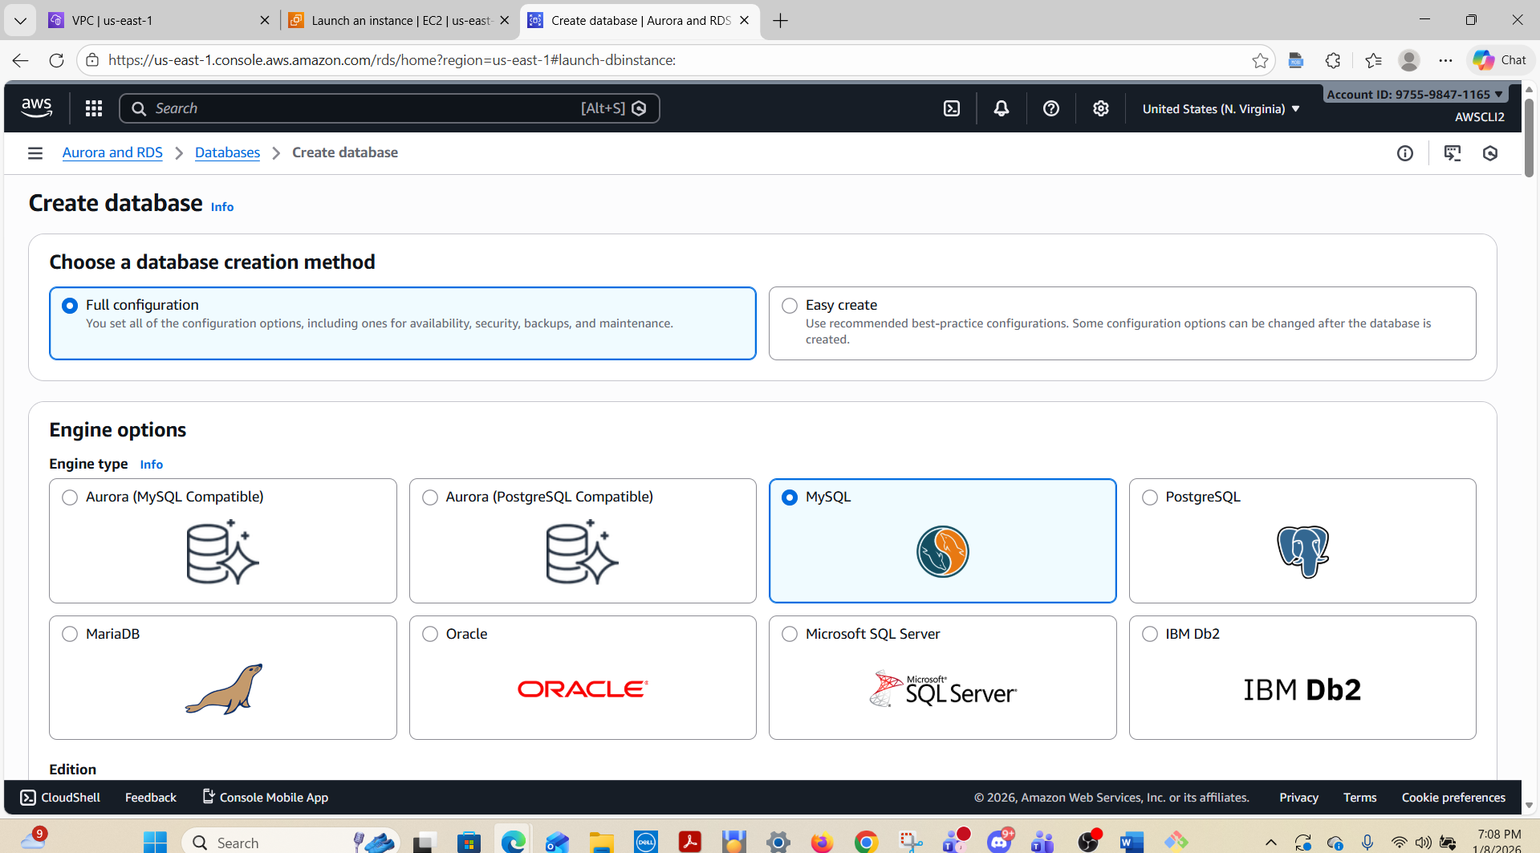

List all security groups in a region:
aws ec2 describe-security-groups \
--group-ids sg-0123456789abcdef0 \
--region us-east-1 \
--output json
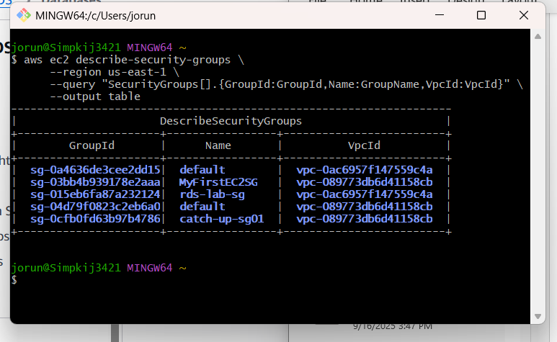

aws ec2 describe-security-groups \
--group-ids sg-0123456789abcdef0 \
--region us-east-1 \
--output json

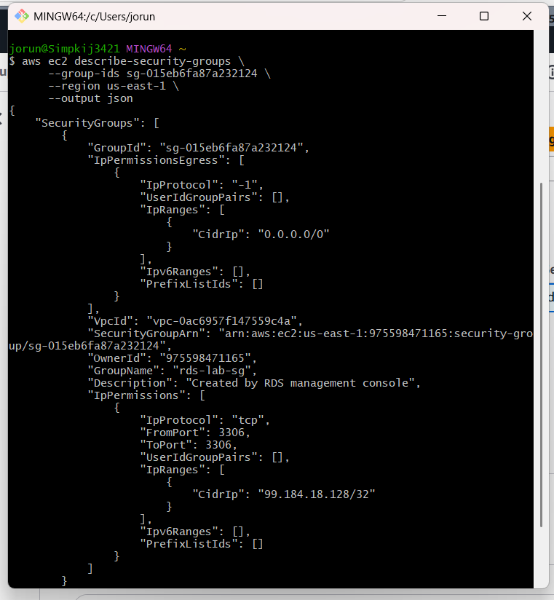

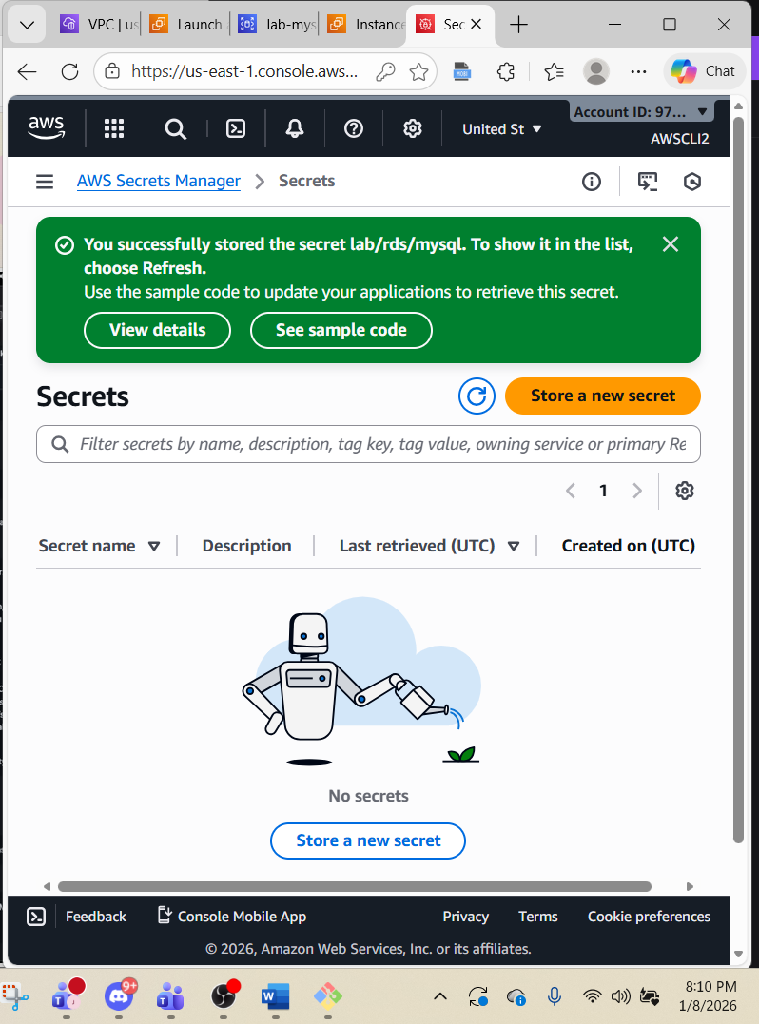
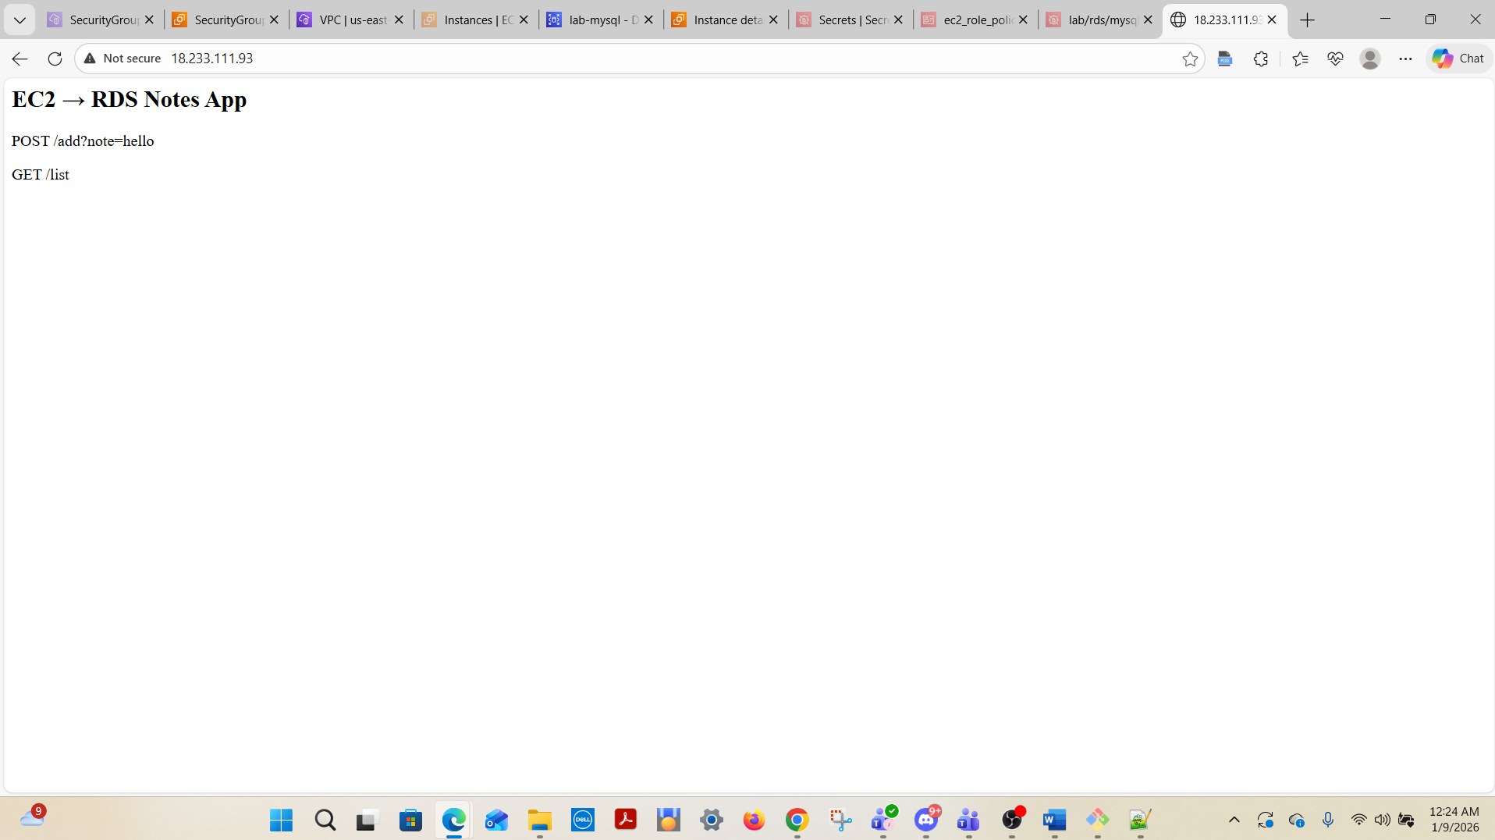

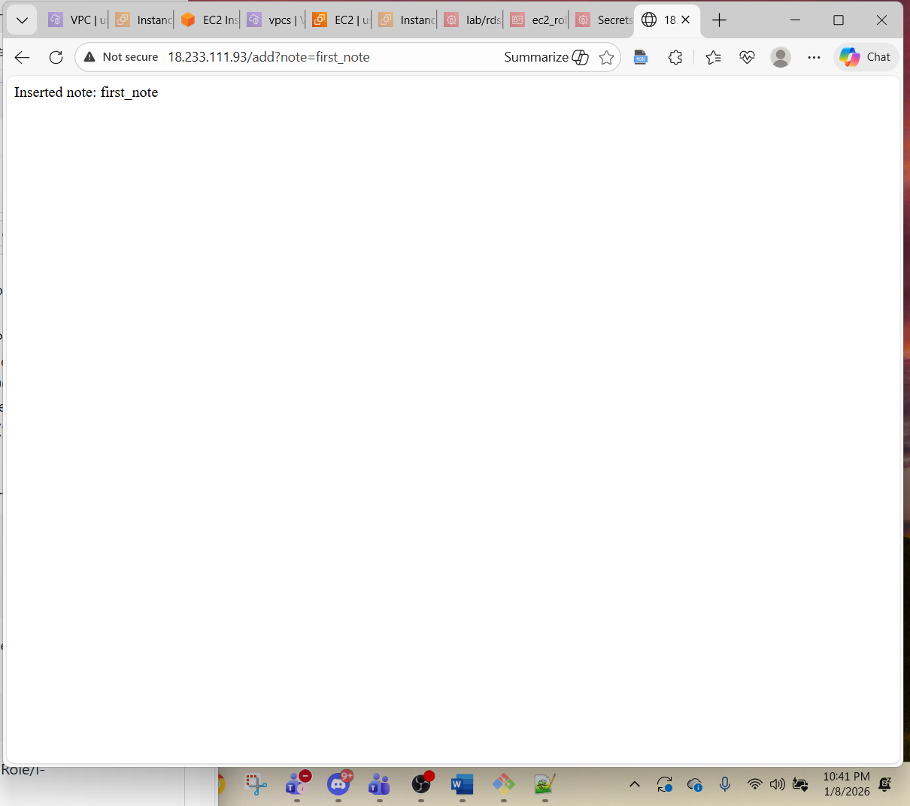

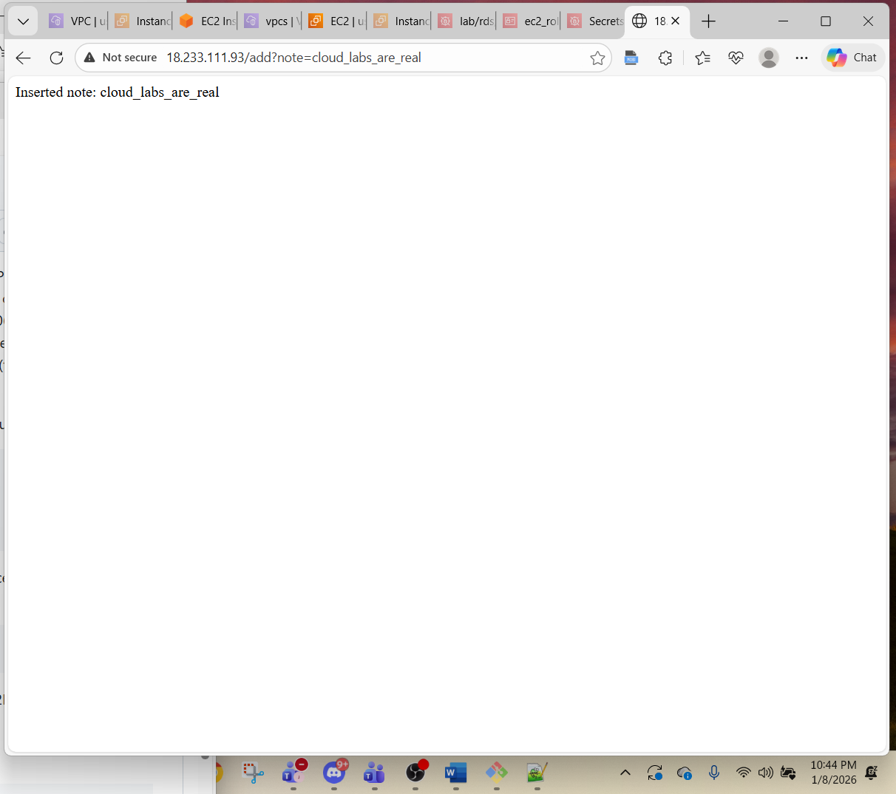

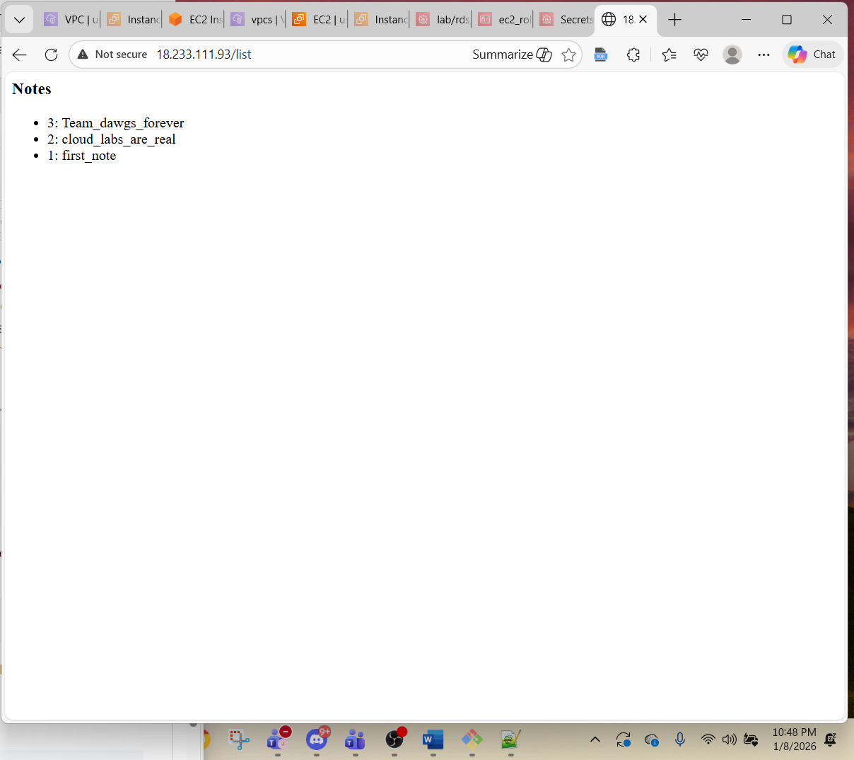

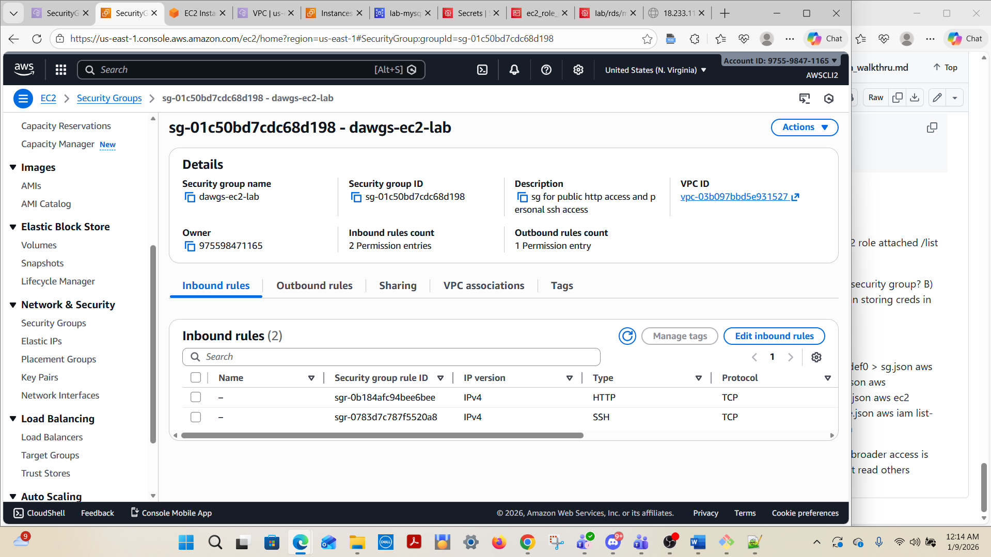
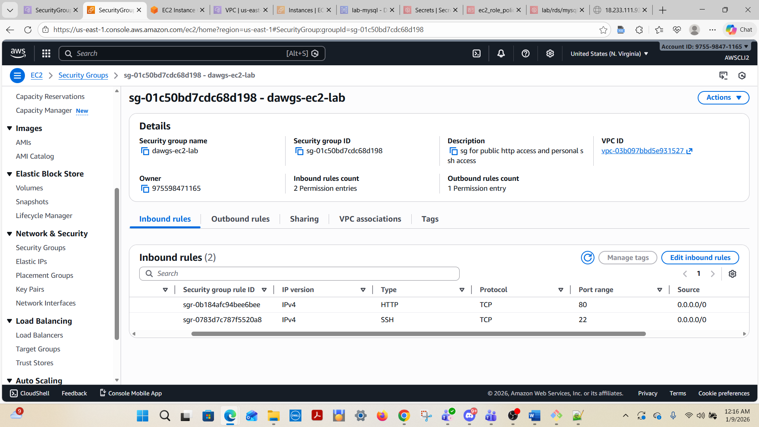

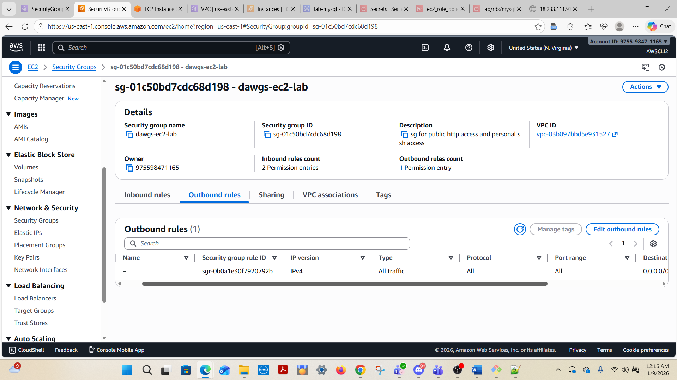

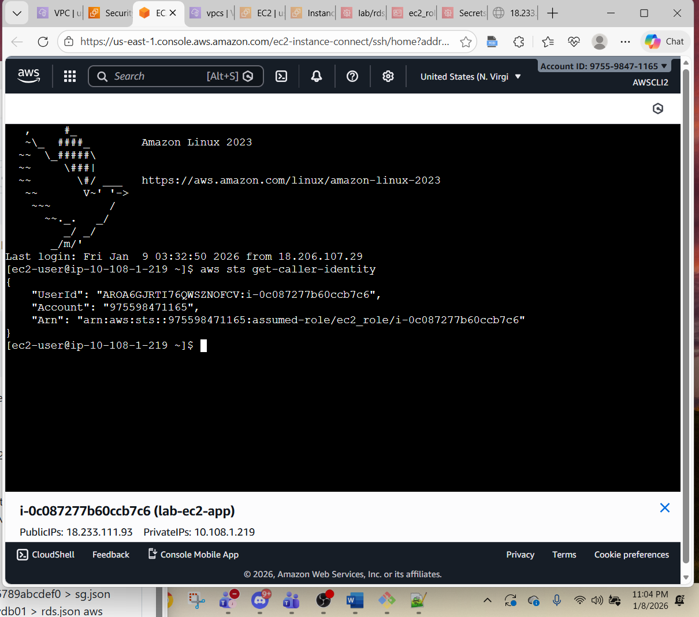

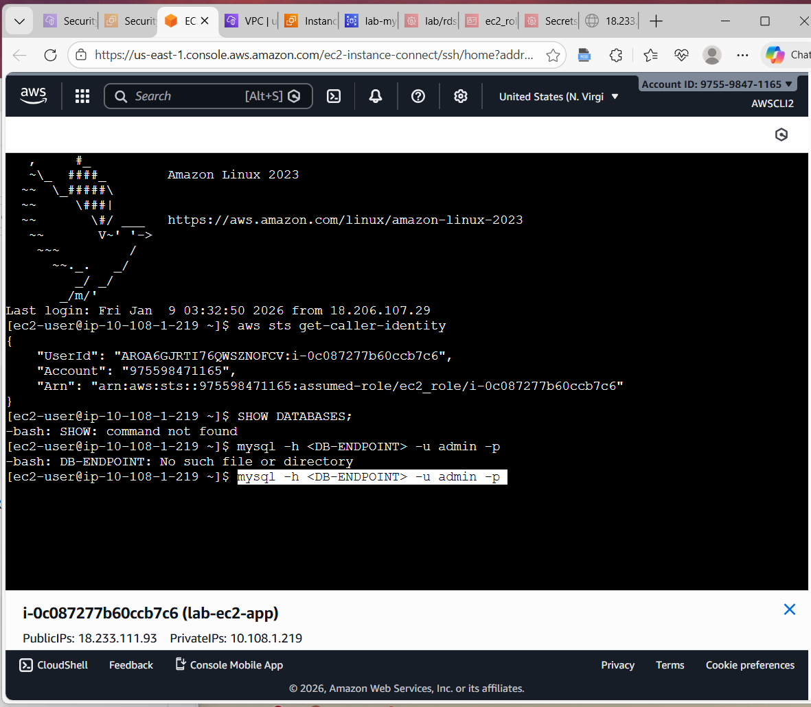

jorun@Simpkij3421 MINGW64 ~
$ aws ec2 describe-security-groups \
--region us-east-1 \
--query "SecurityGroups[].{GroupId:GroupId,Name:GroupName,VpcId:VpcId}" \
--output table
--------------------------------------------------------------------
| DescribeSecurityGroups |
+----------------------+-----------------+-------------------------+
| GroupId | Name | VpcId |
+----------------------+-----------------+-------------------------+
| sg-03bb4b939178e2aaa| MyFirstEC2SG | vpc-089773db6d41158cb |
| sg-0197e02659e026f0f| default | vpc-03b097bbd5e931527 |
| sg-04d79f0823c2eb6a0| default | vpc-089773db6d41158cb |
| sg-01c50bd7cdc68d198| dawgs-ec2-lab | vpc-03b097bbd5e931527 |
| sg-0cfb0fd63b97b4786| catch-up-sg01 | vpc-089773db6d41158cb |
+----------------------+-----------------+-------------------------+

jorun@Simpkij3421 MINGW64 ~
$

jorun@Simpkij3421 MINGW64 ~
$

jorun@Simpkij3421 MINGW64 ~
$

jorun@Simpkij3421 MINGW64 ~
$ aws secretsmanager list-secrets \
--region us-east-1 \
--query "SecretList[].{Name:Name,ARN:ARN,Rotation:RotationEnabled}" \
--output table
-------------------------------------------------------------------------------------------
| ListSecrets
|
+----------+------------------------------------------------------------------------------+
| ARN | arn:aws:secretsmanager:us-east-1:975598471165:secret:lab/rds/mysql-GTK1kE |
| Name | lab/rds/mysql
|
| Rotation| None
|
+----------+------------------------------------------------------------------------------+

jorun@Simpkij3421 MINGW64 ~
$ aws secretsmanager describe-secret \
--secret-id deez-db-secret-nuts \
--region us-east-1 \
--output json

An error occurred (ResourceNotFoundException) when calling the DescribeSecret operation: Secrets Manager can't find the specified secret.

jorun@Simpkij3421 MINGW64 ~
$ aws secretsmanager describe-secret --secret-id lab/rds/mysql --region us-east-1 --output json
{
"ARN": "arn:aws:secretsmanager:us-east-1:975598471165:secret:lab/rds/mysql-GTK1kE",
"Name": "lab/rds/mysql",
"Description": "secret name",
"LastChangedDate": "2026-01-08T20:10:23.849000-05:00",
"Tags": [],
"VersionIdsToStages": {
"46bca41d-9122-4183-a987-215040138ba9": [
"AWSCURRENT"
]
},
"CreatedDate": "2026-01-08T20:10:23.623000-05:00"
}

jorun@Simpkij3421 MINGW64 ~
$ aws secretsmanager get-resource-policy \
--secret-id my-db-secret \
--region us-east-1 \
--output json

An error occurred (ResourceNotFoundException) when calling the GetResourcePolicy operation: Secrets Manager can't find the specified secret.

jorun@Simpkij3421 MINGW64 ~
$ aws secretsmanager get-resource-policy \
--secret-id lab/rds/mysql \
--region us-east-1 \
--output json
{
"ARN": "arn:aws:secretsmanager:us-east-1:975598471165:secret:lab/rds/mysql-GTK1kE",
"Name": "lab/rds/mysql"
}

jorun@Simpkij3421 MINGW64 ~
$ aws ec2 describe-instances \
--filters Name=tag:Name,Values=MyInstance \
--region us-east-1 \
--query "Reservations[].Instances[].InstanceId" \
--output text

jorun@Simpkij3421 MINGW64 ~
$ aws ec2 describe-instances \
--region us-east-1 \
--query "Reservations[].Instances[].InstanceId" \
--output text
i-0c087277b60ccb7c6

jorun@Simpkij3421 MINGW64 ~
$ aws ec2 describe-instances \
--instance-ids i-0c087277b60ccb7c6 \
--region us-east-1 \
--query "Reservations[].Instances[].IamInstanceProfile.Arn" \
--output text
arn:aws:iam::975598471165:instance-profile/ec2_role

jorun@Simpkij3421 MINGW64 ~
$

jorun@Simpkij3421 MINGW64 ~
$ aws iam get-instance-profile \
--instance-profile-name MyEC2Role \
--query "InstanceProfile.Roles[].RoleName" \
--output text

An error occurred (NoSuchEntity) when calling the GetInstanceProfile operation: Instance Profile MyEC2Role cannot be found.

jorun@Simpkij3421 MINGW64 ~
$ aws iam get-instance-profile --instance-profile-name ec2_role --query "InstanceProfile.Roles[].RoleName" --output text
ec2_role

jorun@Simpkij3421 MINGW64 ~
$ aws iam get-instance-profile --instance-profile-name ec2_role --query "InstanceProfile.Roles[].RoleName" --output text
ec2_role

jorun@Simpkij3421 MINGW64 ~
$ aws iam list-attached-role-policies \
--role-name ec2_role \
--output table
---------------------------------------------------------------------------
| ListAttachedRolePolicies |
+-------------------------------------------------------------------------+
|| AttachedPolicies ||
|+---------------------------------------------------+-------------------+|
|| PolicyArn | PolicyName ||
|+---------------------------------------------------+-------------------+|
|| arn:aws:iam::975598471165:policy/ec2_role_policy | ec2_role_policy ||
|+---------------------------------------------------+-------------------+|

jorun@Simpkij3421 MINGW64 ~
$ aws iam list-role-policies \
--role-name ec2_role \
--output table
------------------
|ListRolePolicies|
+----------------+

jorun@Simpkij3421 MINGW64 ~
$ ^[[200~aws iam get-policy-version \
> --policy-arn arn:aws:iam::aws:policy/SecretsManagerReadWrite \
> --version-id v1 \
> ^[[200~aws iam get-policy-version --policy-arn arn:aws:iam::aws:policy/SecretsManagerReadWrite --version-id v1 \
>
GNU bash, version 5.2.37(1)-release (x86_64-pc-msys)
>
bash: $'\E[200~aws': command not found

jorun@Simpkij3421 MINGW64 ~
$ aws iam get-policy-version \
--policy-arn arn:aws:iam::aws:policy/SecretsManagerReadWrite \
--version-id v1 \
--output json
{
"PolicyVersion": {
"Document": {
"Version": "2012-10-17",
"Statement": [
{
"Action": [
"secretsmanager:*",
"cloudformation:CreateChangeSet",
"cloudformation:DescribeChangeSet",
"cloudformation:DescribeStackResource",
"cloudformation:DescribeStacks",
"cloudformation:ExecuteChangeSet",
"ec2:DescribeSecurityGroups",
"ec2:DescribeSubnets",
"ec2:DescribeVpcs",
"kms:DescribeKey",
"kms:ListAliases",
"kms:ListKeys",
"lambda:ListFunctions",
"rds:DescribeDBInstances",
"tag:GetResources"
],
"Effect": "Allow",
"Resource": "*"
},
{
"Action": [
"lambda:AddPermission",
"lambda:CreateFunction",
"lambda:GetFunction",
"lambda:InvokeFunction",
"lambda:UpdateFunctionConfiguration"
],
"Effect": "Allow",
"Resource": "arn:aws:lambda:*:*:function:SecretsManager*"
},
{
"Action": [
"serverlessrepo:CreateCloudFormationChangeSet"
],
"Effect": "Allow",
"Resource": "arn:aws:serverlessrepo:*:*:applications/SecretsManager*"
},
{
"Action": [
"s3:GetObject"
],
"Effect": "Allow",
"Resource": "arn:aws:s3:::awsserverlessrepo-changesets*"
}
]
},
"VersionId": "v1",
"IsDefaultVersion": false,
"CreateDate": "2018-04-04T18:05:29+00:00"
}
}

jorun@Simpkij3421 MINGW64 ~
$

jorun@Simpkij3421 MINGW64 ~
$

jorun@Simpkij3421 MINGW64 ~
$ aws iam get-policy-version \
--policy-arn arn:aws:iam::aws:policy/ec2_role_policy \
--version-id v1 \
--output json

An error occurred (NoSuchEntity) when calling the GetPolicyVersion operation: Policy arn:aws:iam::aws:policy/ec2_role_policy version v1 does not exist or is not attachable.

jorun@Simpkij3421 MINGW64 ~
$ aws iam get-policy-version --policy-arn arn:aws:iam::975598471165:policy/ec2_role_policy --version-id v1 --output json
{
"PolicyVersion": {
"Document": {
"Version": "2012-10-17",
"Statement": [
{
"Sid": "ReadOnlyListActions",
"Effect": "Allow",
"Action": [
"ec2:DescribeInstances",
"ec2:DescribeSecurityGroups",
"rds:DescribeDBInstances"
],
"Resource": "*"
},
{
"Sid": "ReadSpecificSecret",
"Effect": "Allow",
"Action": [
"secretsmanager:GetSecretValue"
],
"Resource": "arn:aws:secretsmanager:us-east-1:975598471165:secret:lab/rds/mysql*"
}
]
},
"VersionId": "v1",
"IsDefaultVersion": true,
"CreateDate": "2026-01-09T01:52:05+00:00"
}
}

jorun@Simpkij3421 MINGW64 ~
$

jorun@Simpkij3421 MINGW64 ~
$ aws ec2 describe-security-groups \
--group-ids sg-ec2-access \
--region us-east-1 \
--query "SecurityGroups[].IpPermissions"

An error occurred (InvalidGroupId.Malformed) when calling the DescribeSecurityGroups operation: Invalid id: "sg-ec2-access"

jorun@Simpkij3421 MINGW64 ~
$ aws ec2 describe-security-groups --group-ids sg-01c50bd7cdc68d198 --region us-east-1 --query "SecurityGroups[].IpPermissions"
[
[
{
"IpProtocol": "tcp",
"FromPort": 80,
"ToPort": 80,
"UserIdGroupPairs": [],
"IpRanges": [
{
"Description": "public http access",
"CidrIp": "0.0.0.0/0"
}
],
"Ipv6Ranges": [],
"PrefixListIds": []
},
{
"IpProtocol": "tcp",
"FromPort": 22,
"ToPort": 22,
"UserIdGroupPairs": [],
"IpRanges": [
{
"Description": "ssh",
"CidrIp": "0.0.0.0/0"
}
],
"Ipv6Ranges": [],
"PrefixListIds": []
}
]
]

jorun@Simpkij3421 MINGW64 ~
$ aws sts get-caller-identity
{
"UserId": "AIDA6GJRTI765UEFNJMUZ",
"Account": "975598471165",
"Arn": "arn:aws:iam::975598471165:user/AWSCLI4"
}

jorun@Simpkij3421 MINGW64 ~
$ aws secretsmanager describe-secret \
--secret-id my-db-secret \
--region us-east-1

An error occurred (ResourceNotFoundException) when calling the DescribeSecret operation: Secrets Manager can't find the specified secret.

jorun@Simpkij3421 MINGW64 ~
$ aws secretsmanager describe-secret \
--secret-id lab/rds/mysql \
--region us-east-1
{
"ARN": "arn:aws:secretsmanager:us-east-1:975598471165:secret:lab/rds/mysql-GTK1kE",
"Name": "lab/rds/mysql",
"Description": "secret name",
"LastChangedDate": "2026-01-08T20:10:23.849000-05:00",
"LastAccessedDate": "2026-01-08T19:00:00-05:00",
"Tags": [],
"VersionIdsToStages": {
"46bca41d-9122-4183-a987-215040138ba9": [
"AWSCURRENT"
]
},
"CreatedDate": "2026-01-08T20:10:23.623000-05:00"
}

jorun@Simpkij3421 MINGW64 ~
$

, #_
~\_ ####_ Amazon Linux 2023
~~ \_#####\
~~ \###|
~~ \#/ ___ https://aws.amazon.com/linux/amazon-linux-2023
~~ V~' '->
~~~ /
~~._. _/
_/ _/
_/m/'
Last login: Fri Jan 9 04:17:22 2026 from 18.206.107.28
[ec2-user@ip-10-108-1-219 ~]$ mysql -h lab-mysql.con8om0ygium.us-east-1.rds.amazonaws.com -u admin -p
Enter password:
Welcome to the MariaDB monitor. Commands end with ; or \g.
Your MySQL connection id is 109
Server version: 8.0.43 Source distribution

Copyright (c) 2000, 2018, Oracle, MariaDB Corporation Ab and others.

Type 'help;' or '\h' for help. Type '\c' to clear the current input statement.

MySQL [(none)]> SHOW DATABASES;
+--------------------+
| Database |
+--------------------+
| information_schema |
| labdb |
| mysql |
| performance_schema |
| sys |
+--------------------+
5 rows in set (0.012 sec)

MySQL [(none)]> CREATE DATABASE labdb2;
Query OK, 1 row affected (0.018 sec)

MySQL [(none)]> SHOW DATABASES;
+--------------------+
| Database |
+--------------------+
| information_schema |
| labdb |
| labdb2 |
| mysql |
| performance_schema |
| sys |
+--------------------+
6 rows in set (0.009 sec)

MySQL [(none)]>

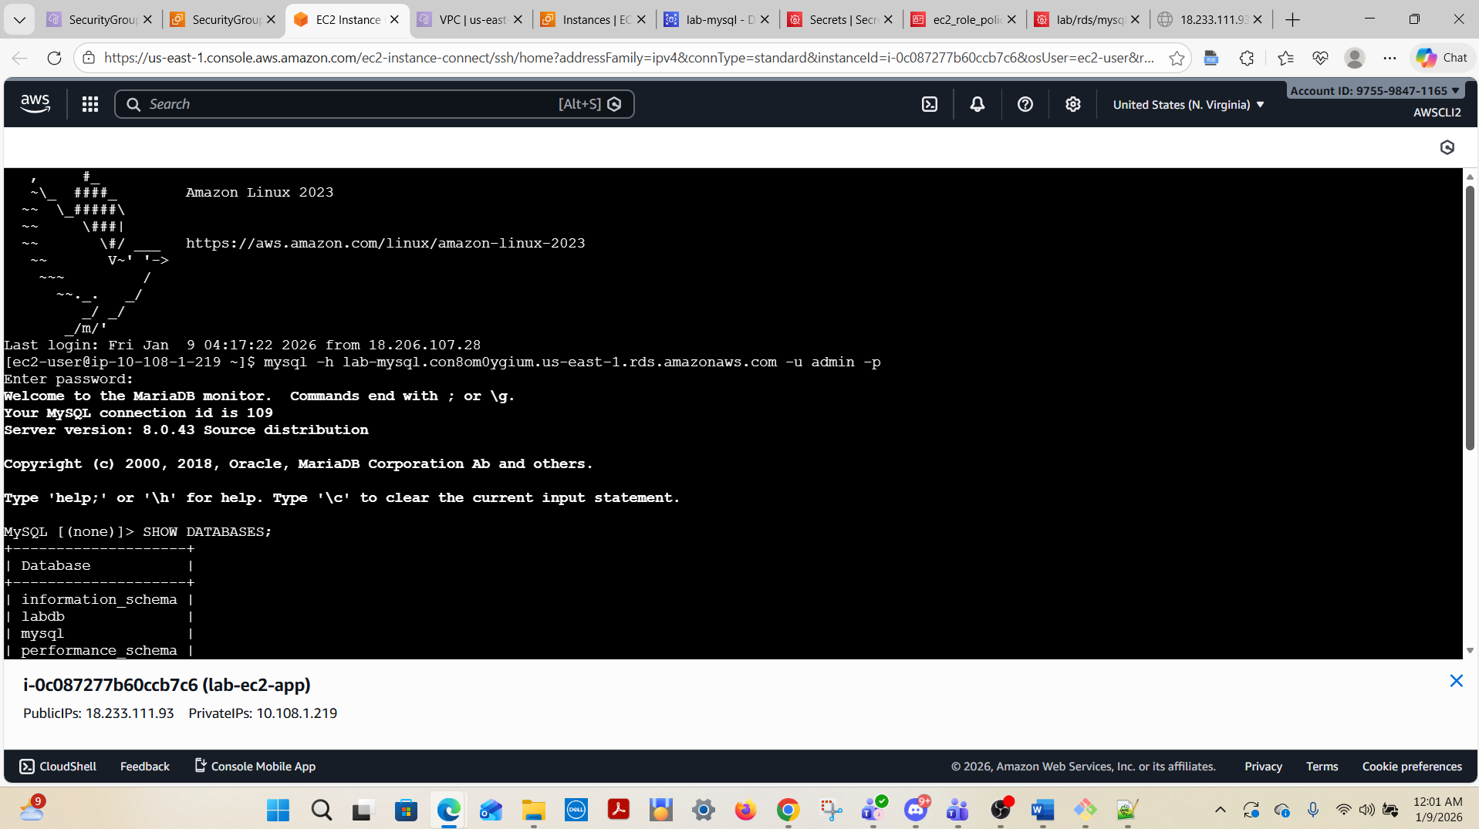

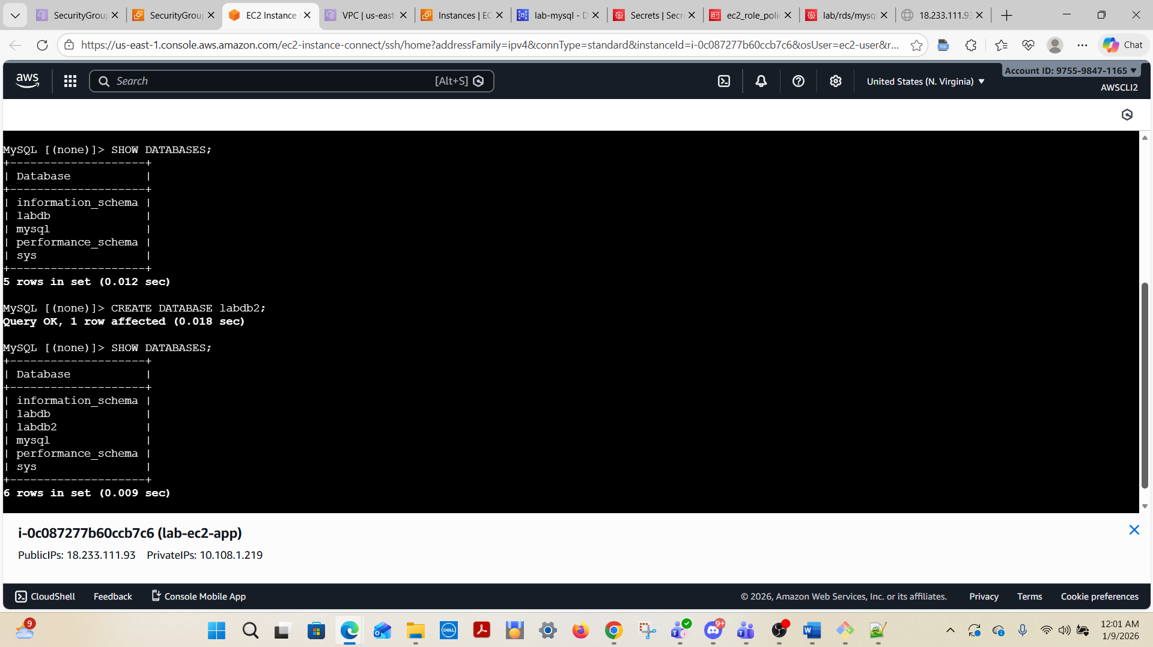

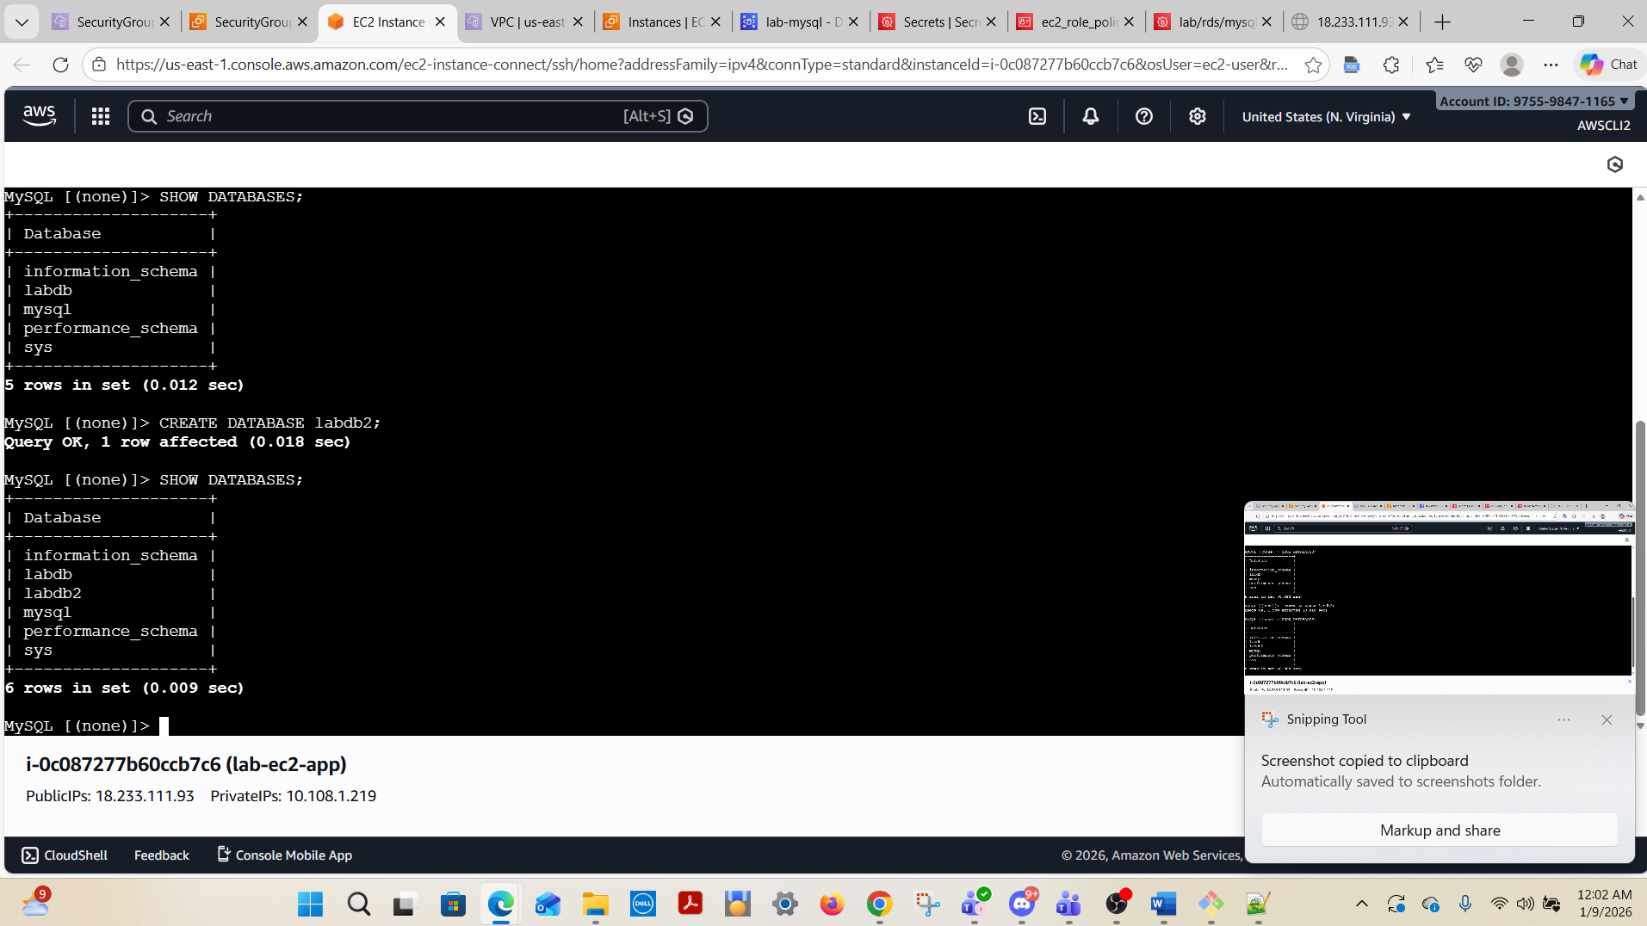

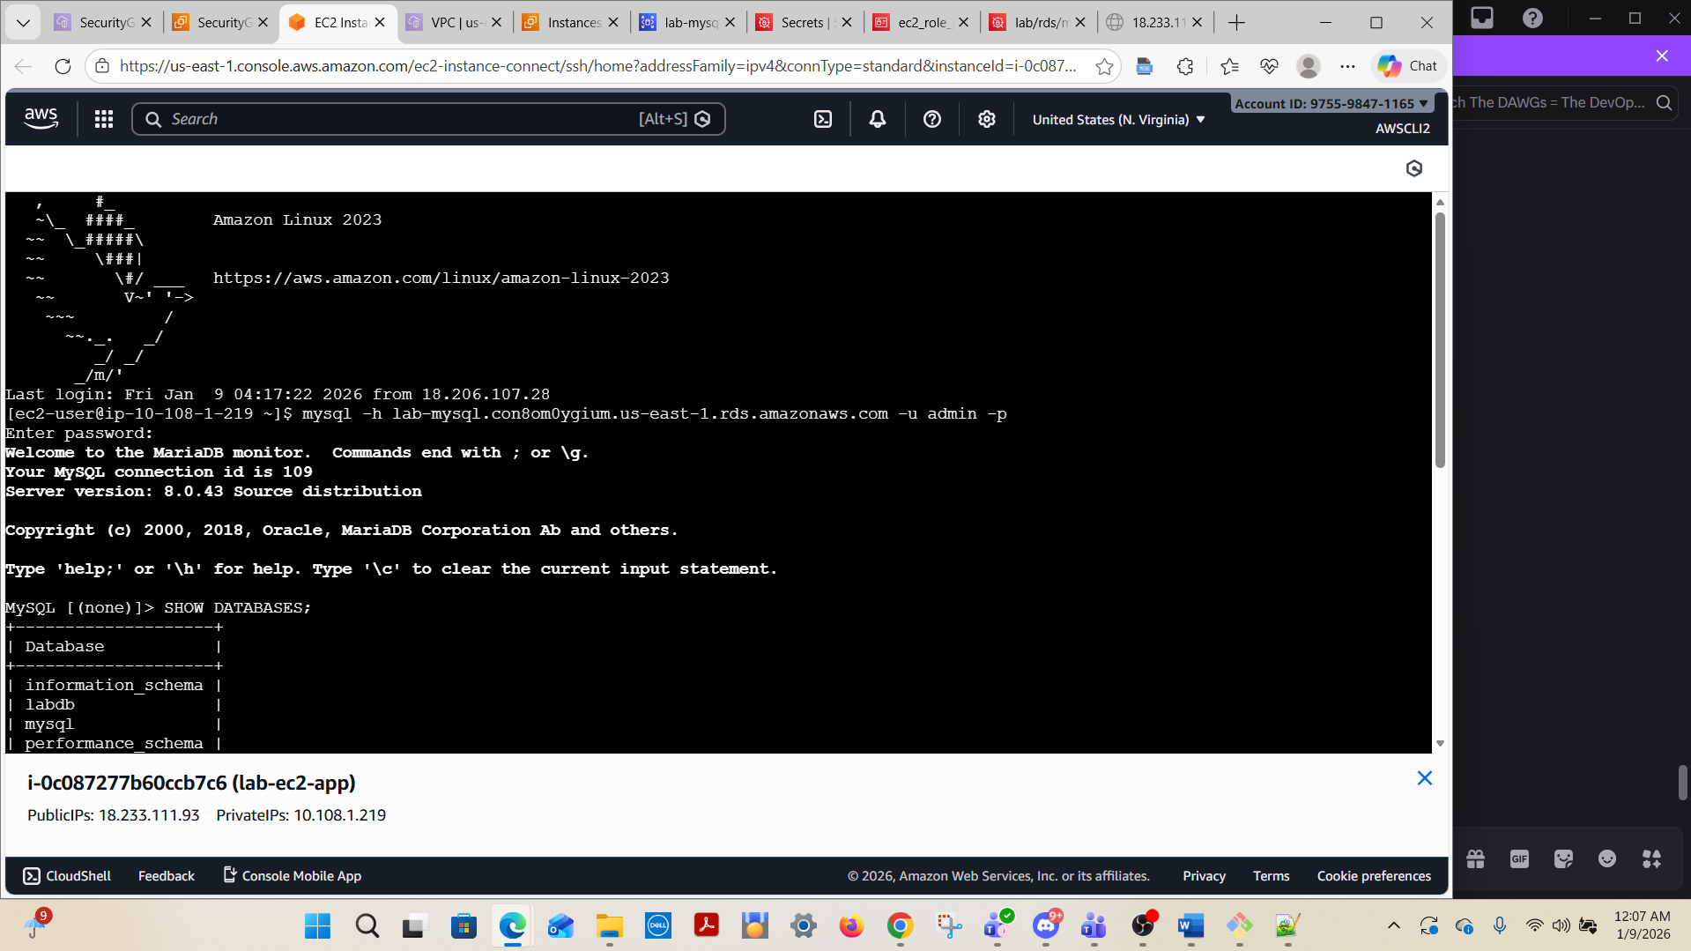

aws rds describe-db-instances \
--region us-east-1 \
--query "DBInstances[?contains(VpcSecurityGroups[].VpcSecurityGroupId, 'sg-0123456789abcdef0')].DBInstanceIdentifier" \
--output table
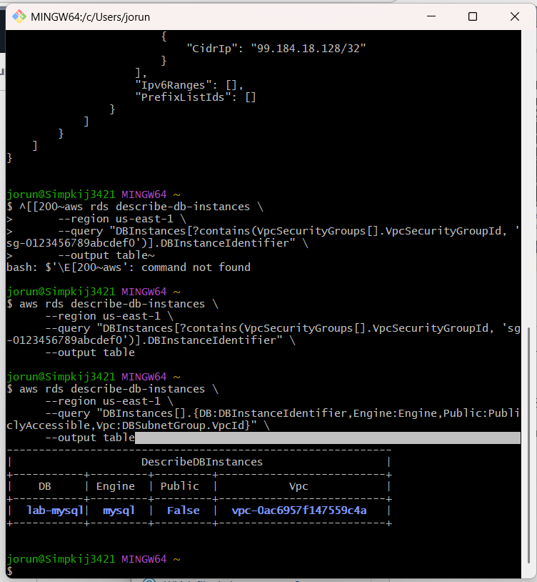

aws rds describe-db-instances \
--region us-east-1 \
--query "DBInstances[].{DB:DBInstanceIdentifier,Engine:Engine,Public:PubliclyAccessible,Vpc:DBSubnetGroup.VpcId}" \
--output table
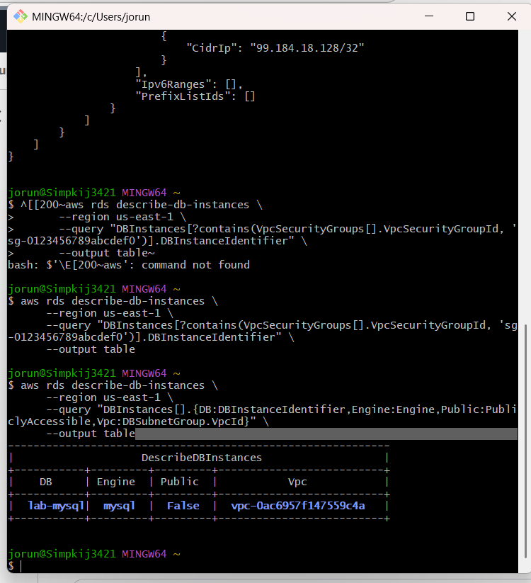
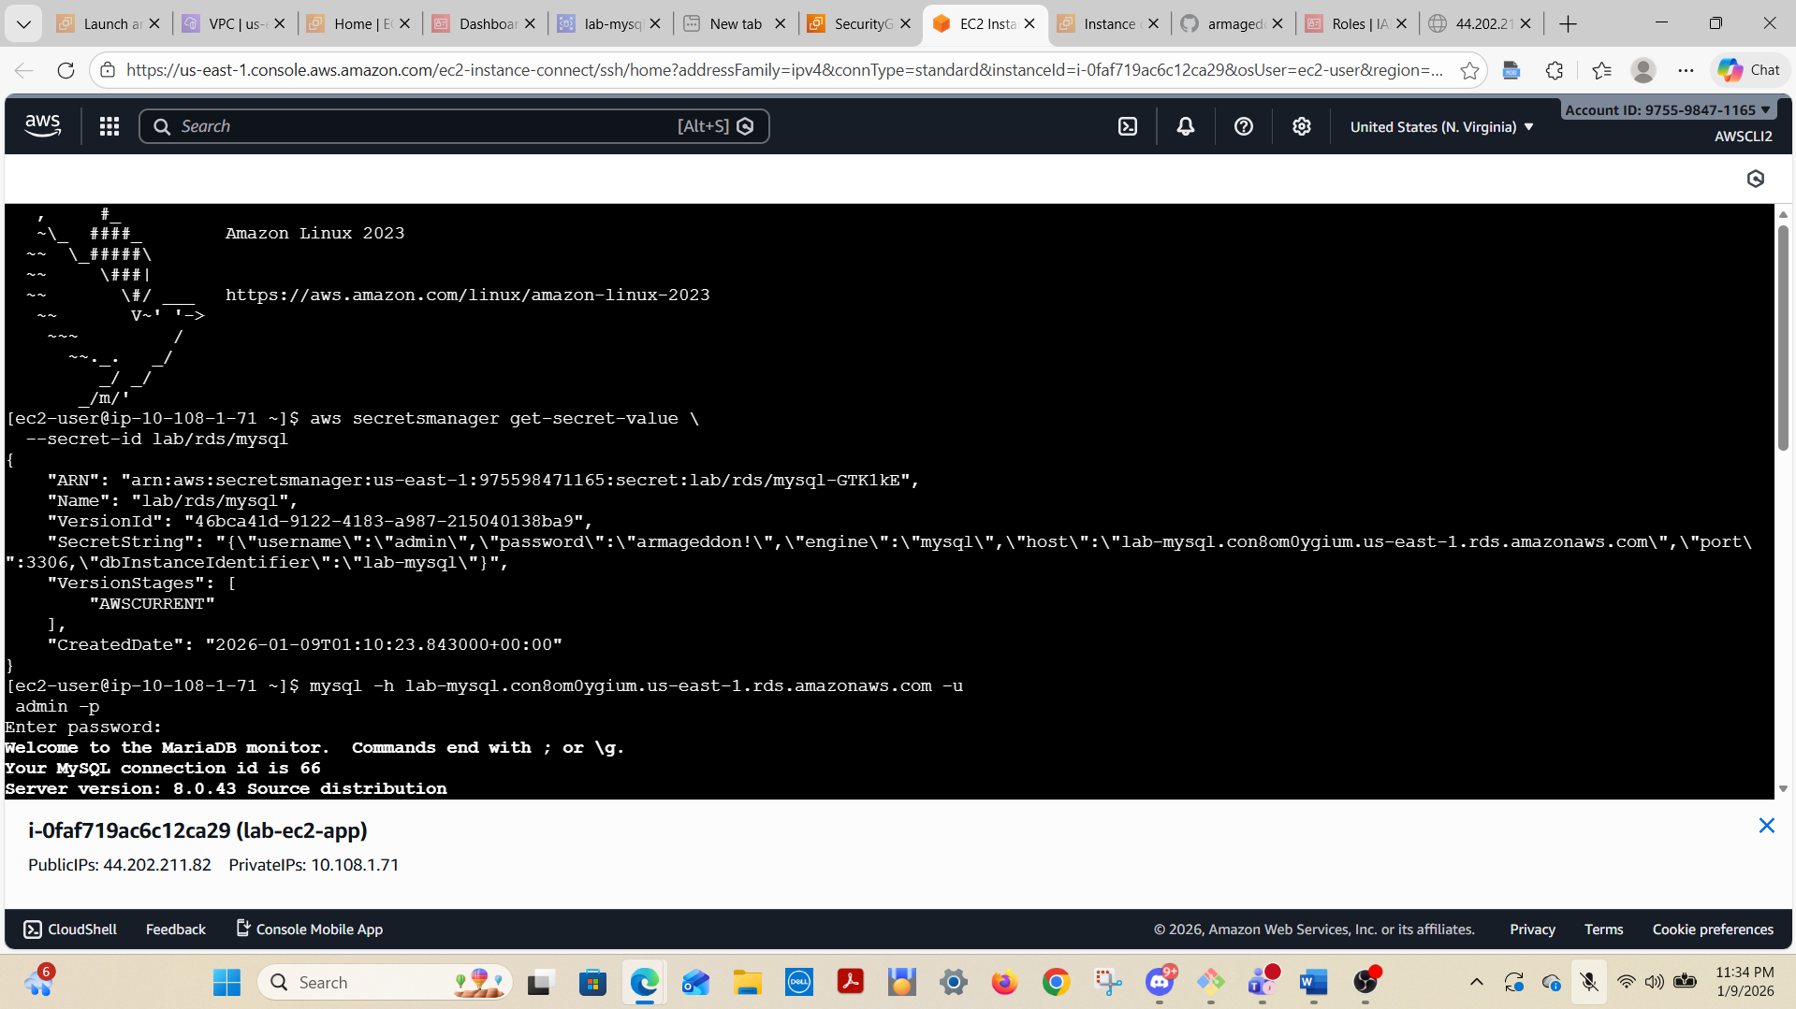

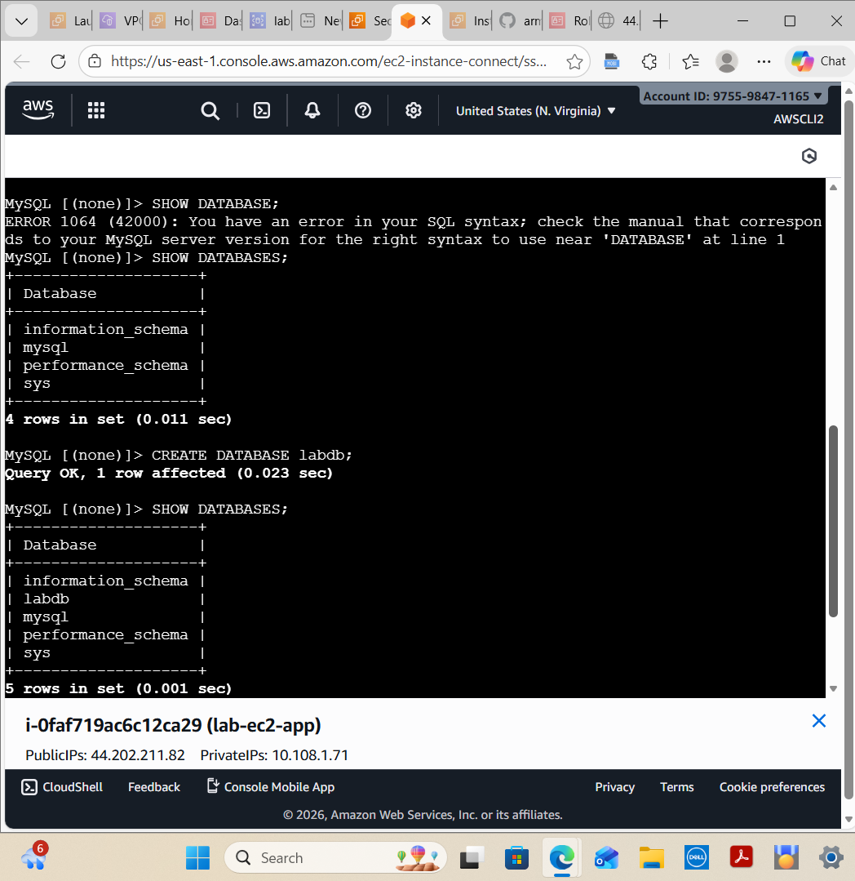

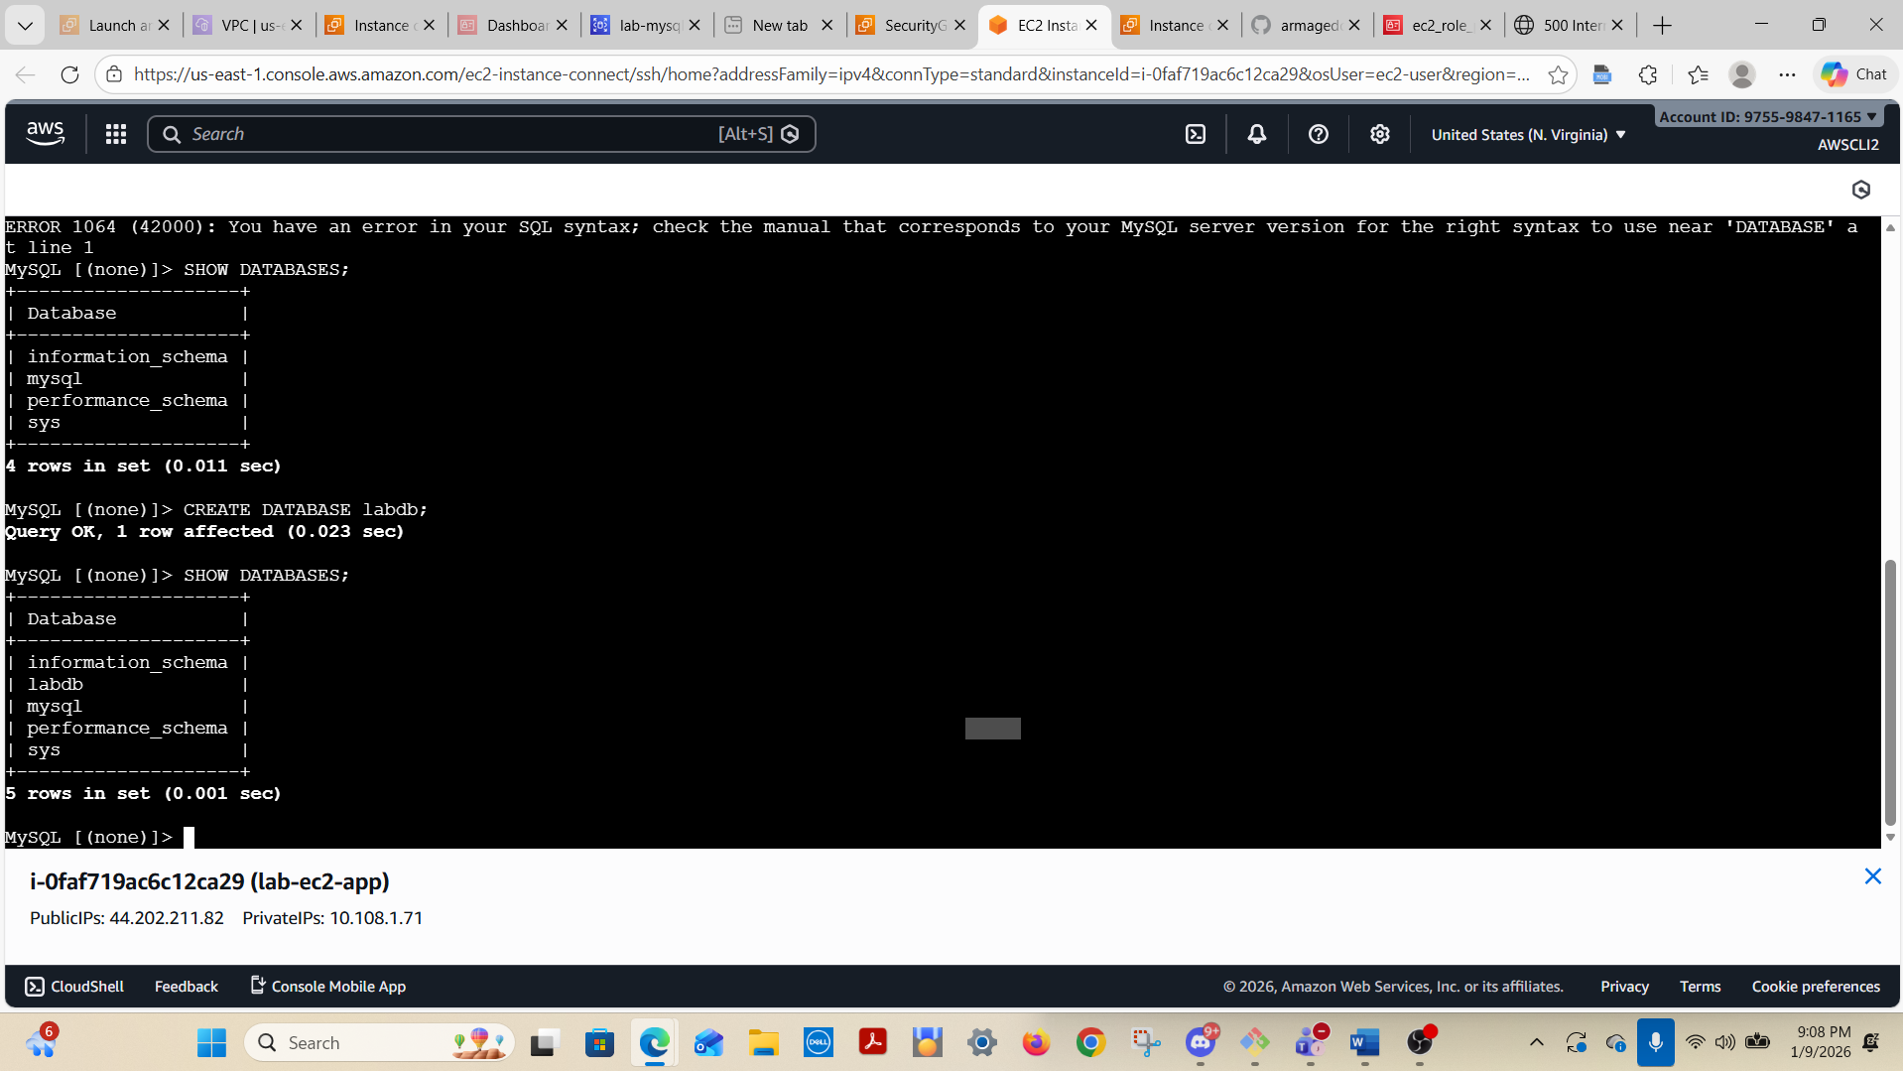

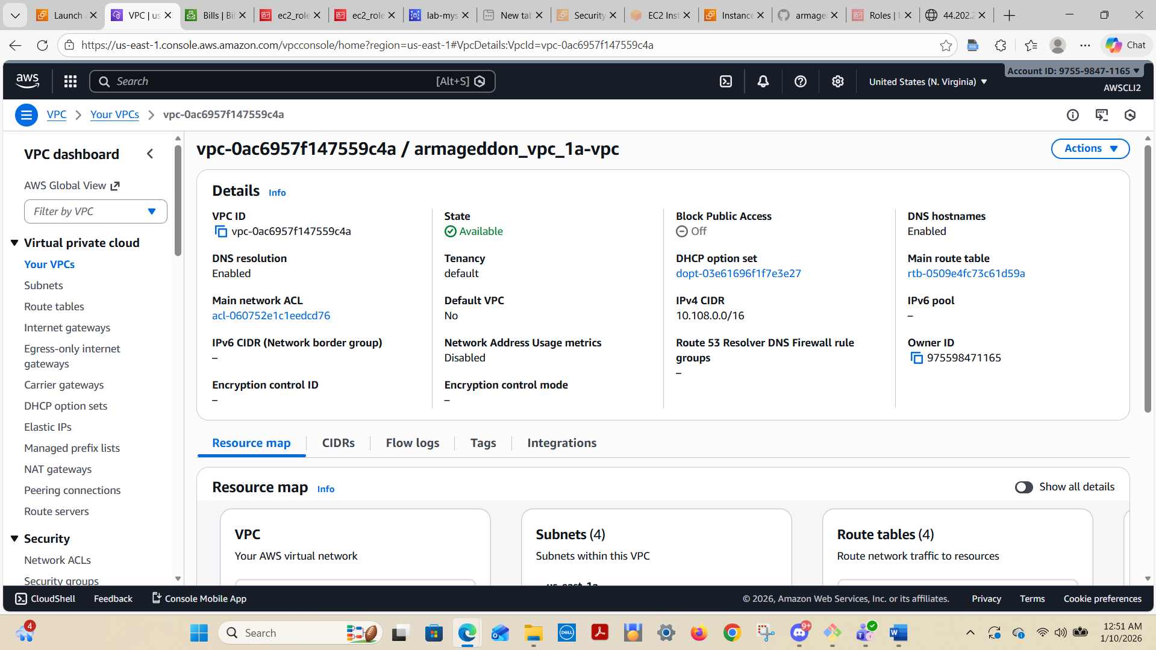
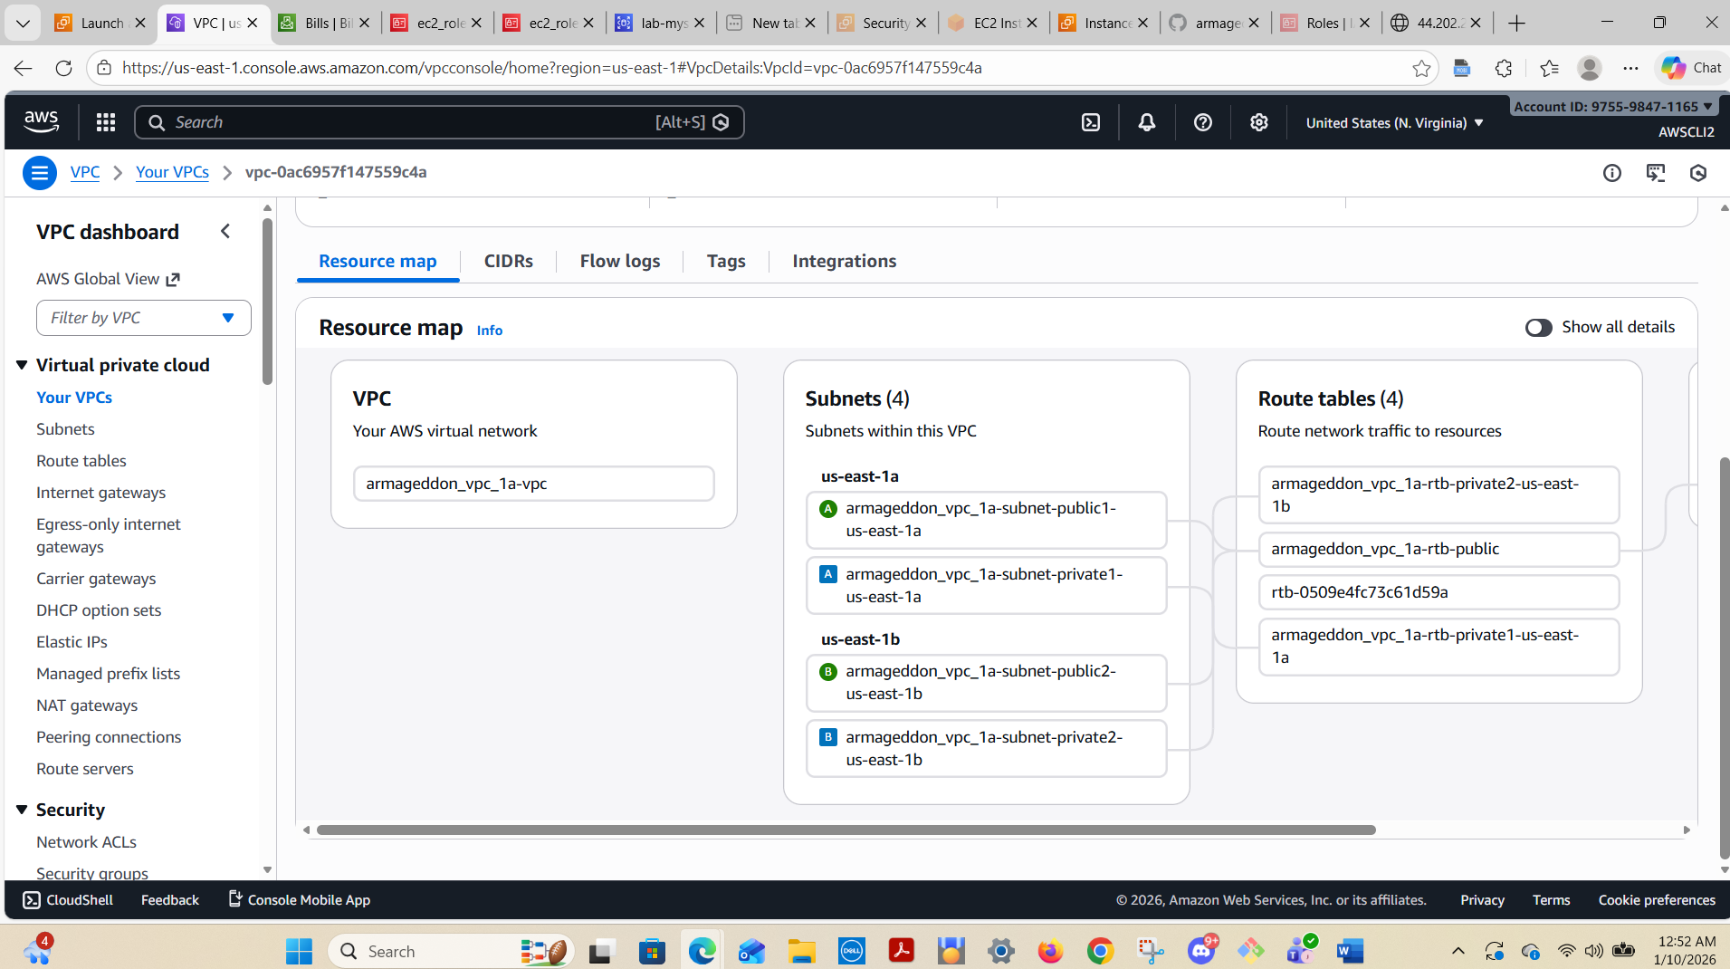

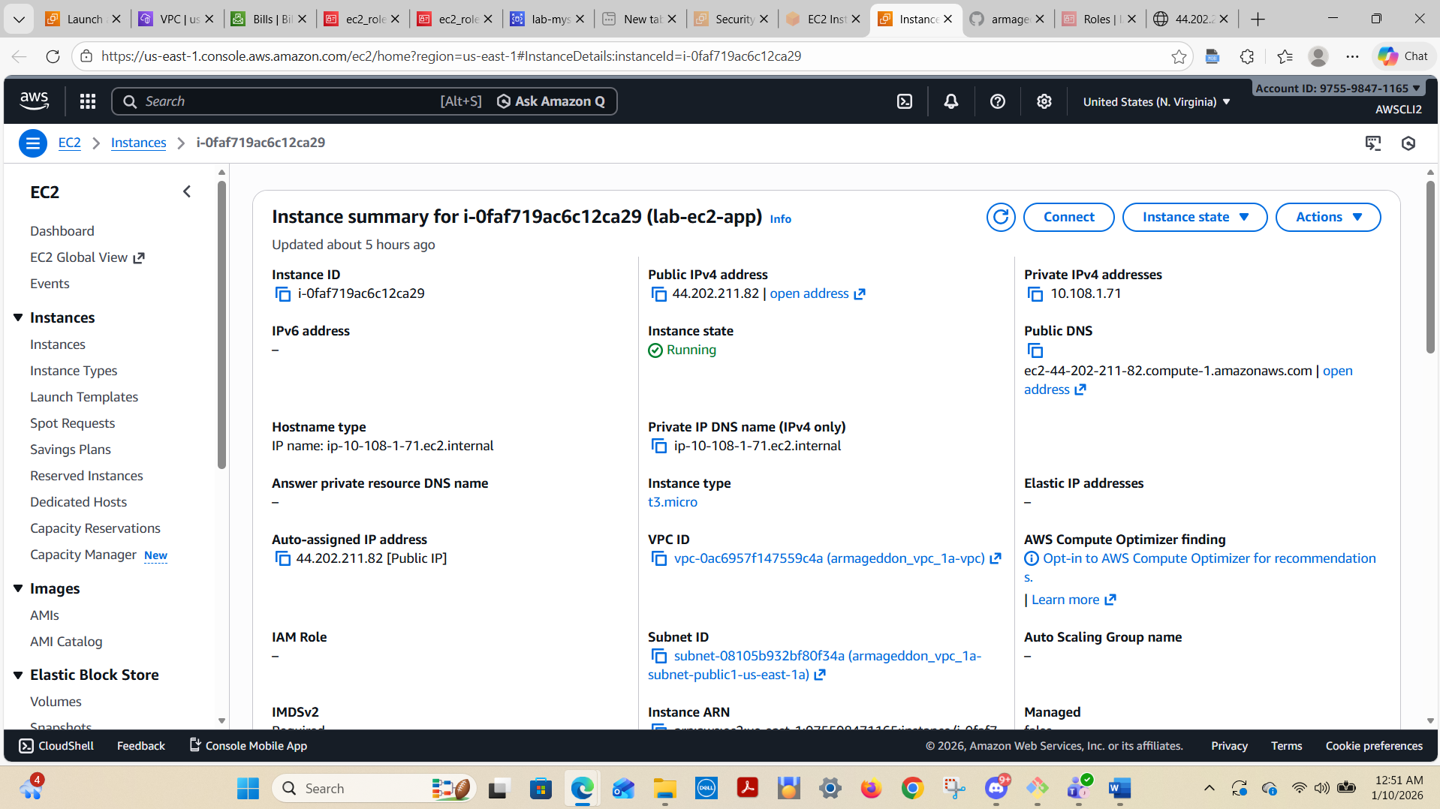

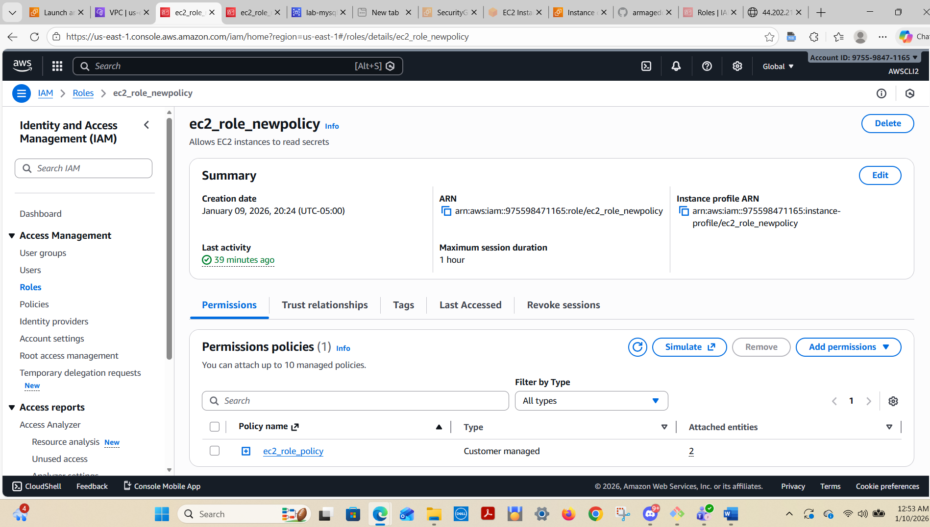

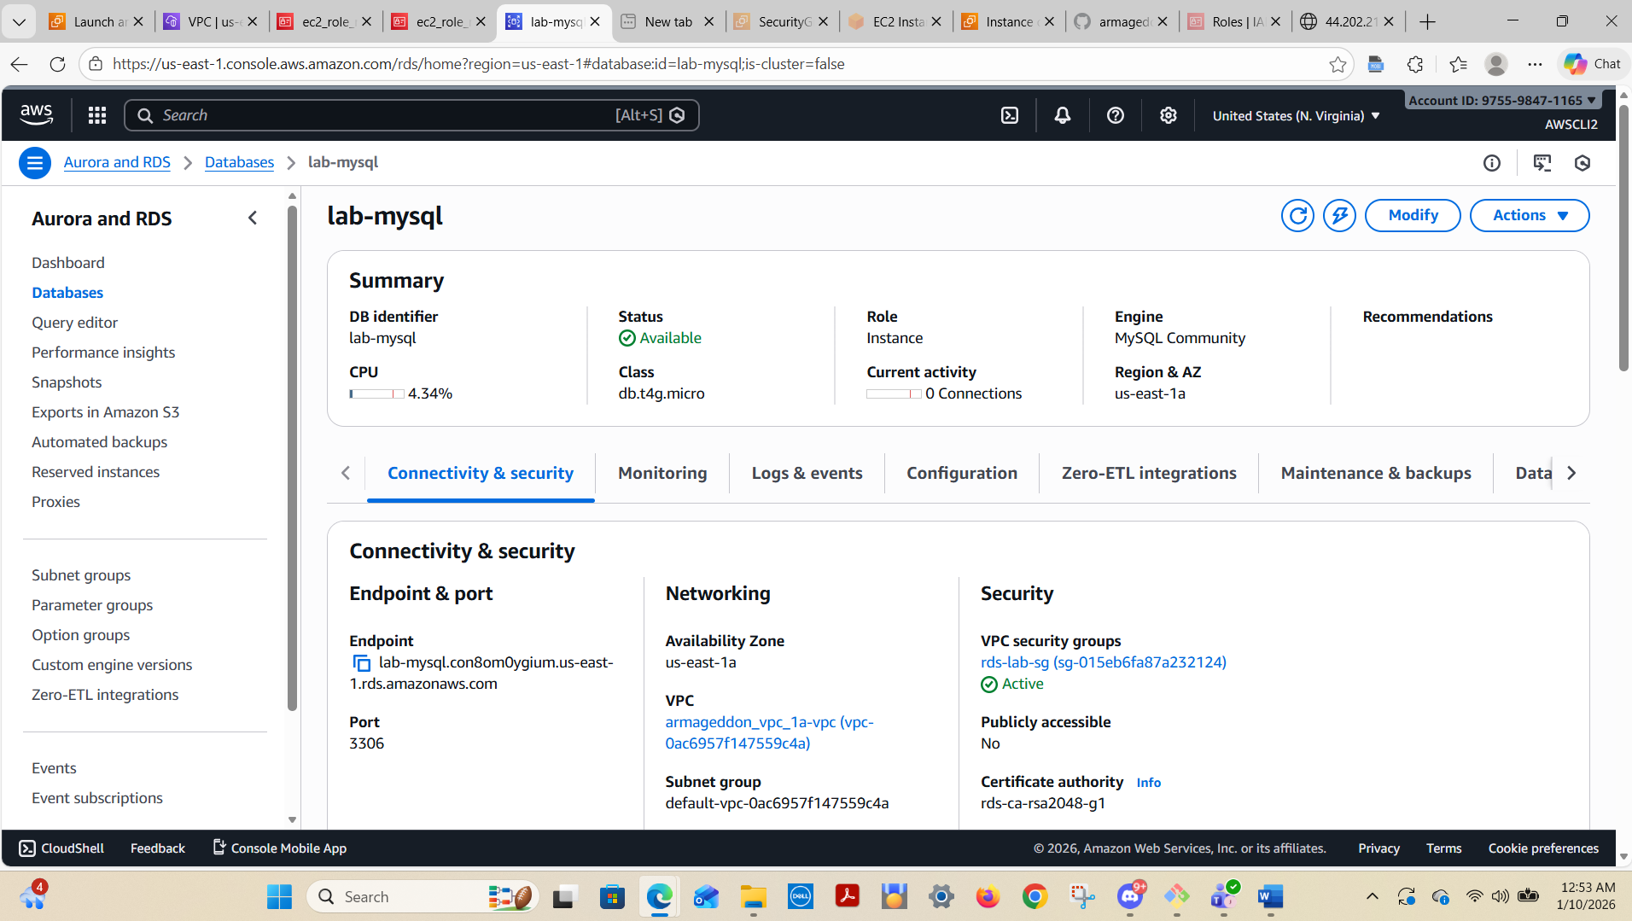

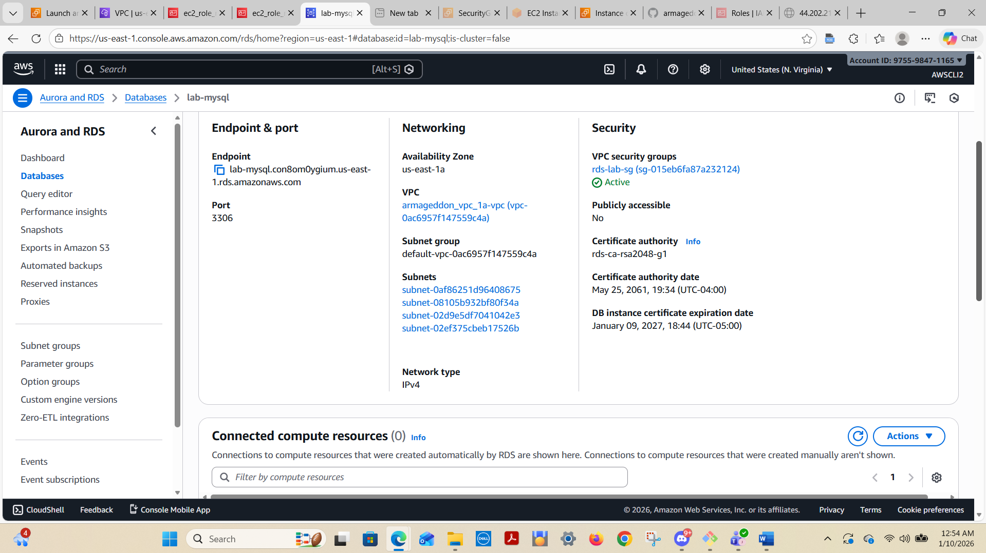
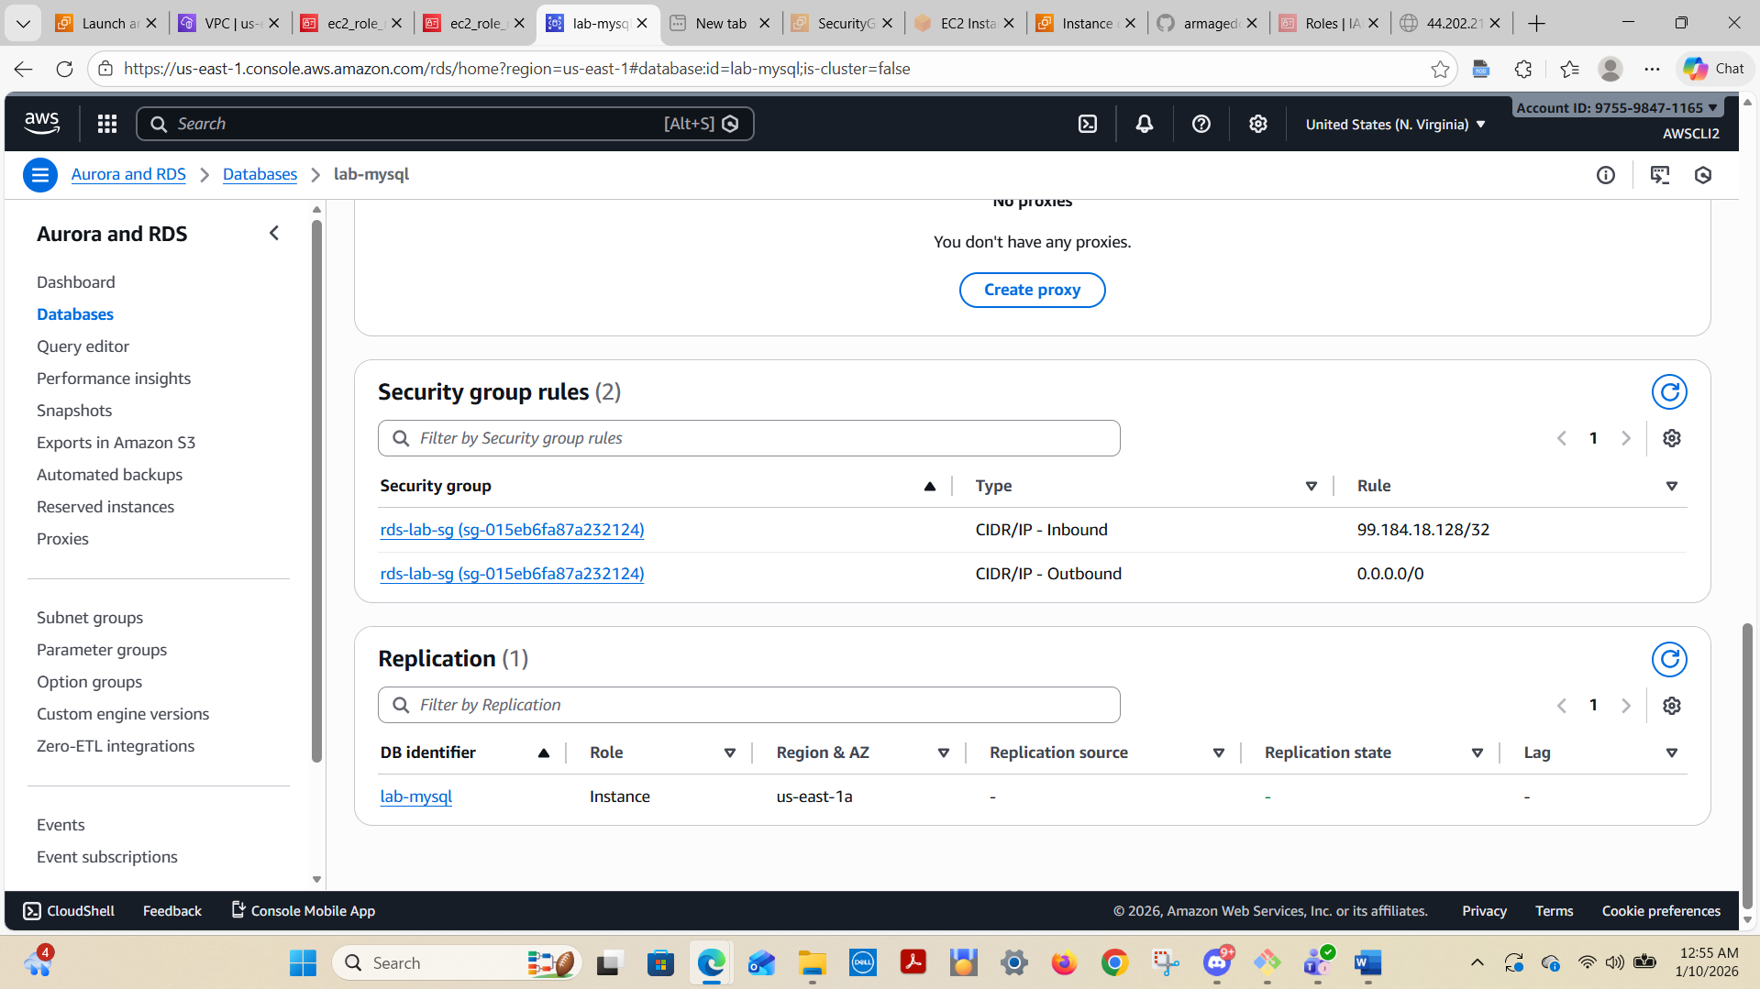
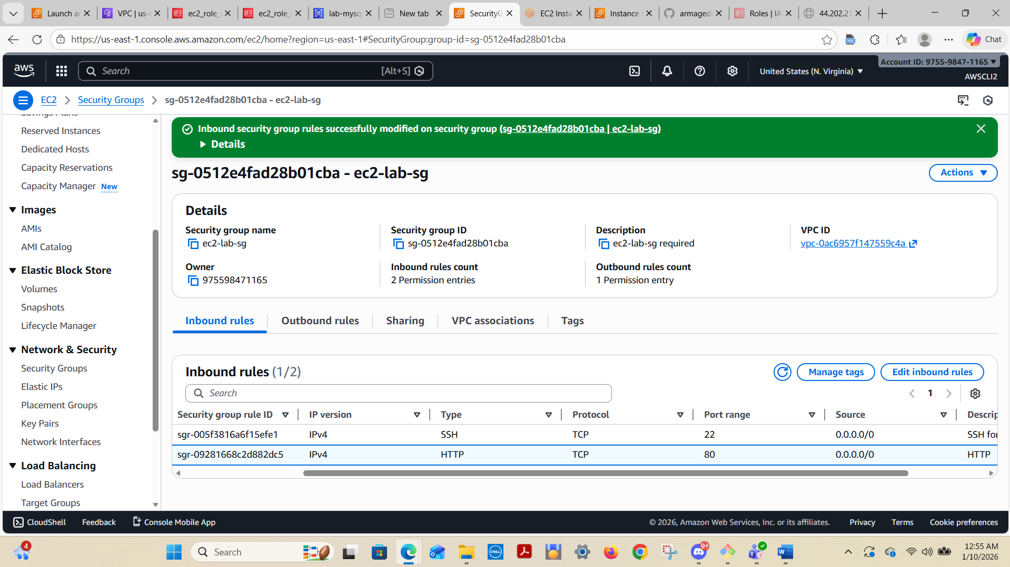
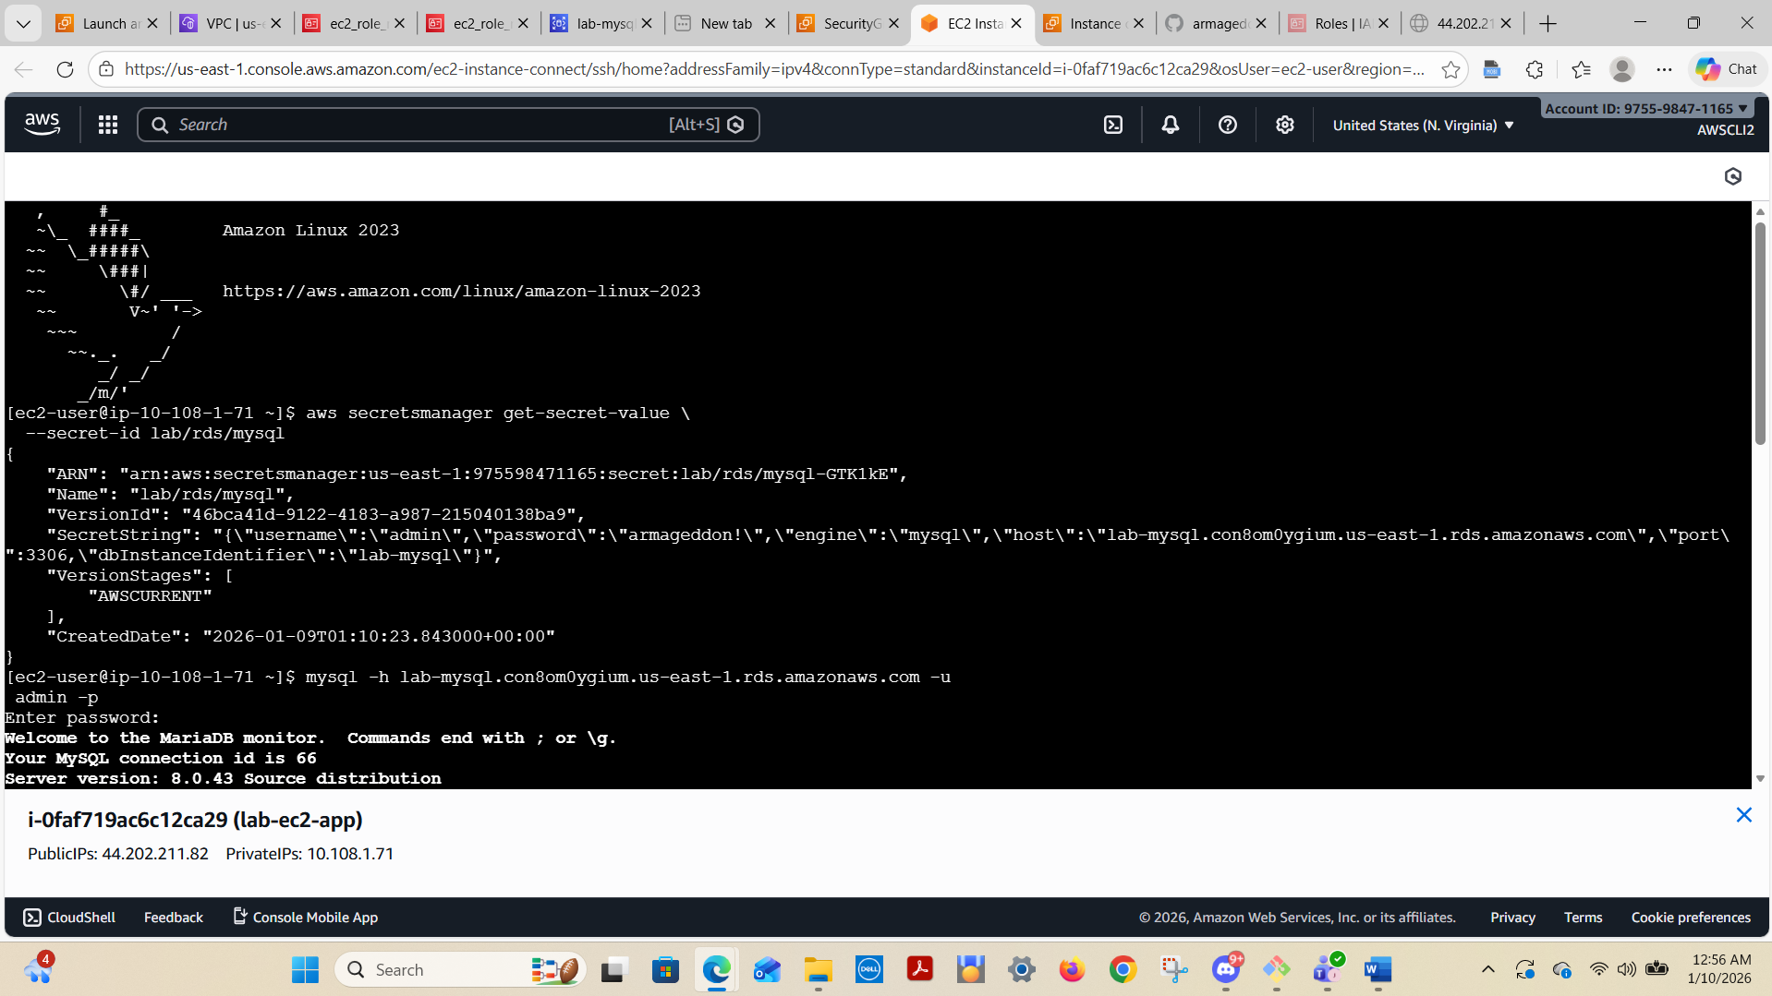

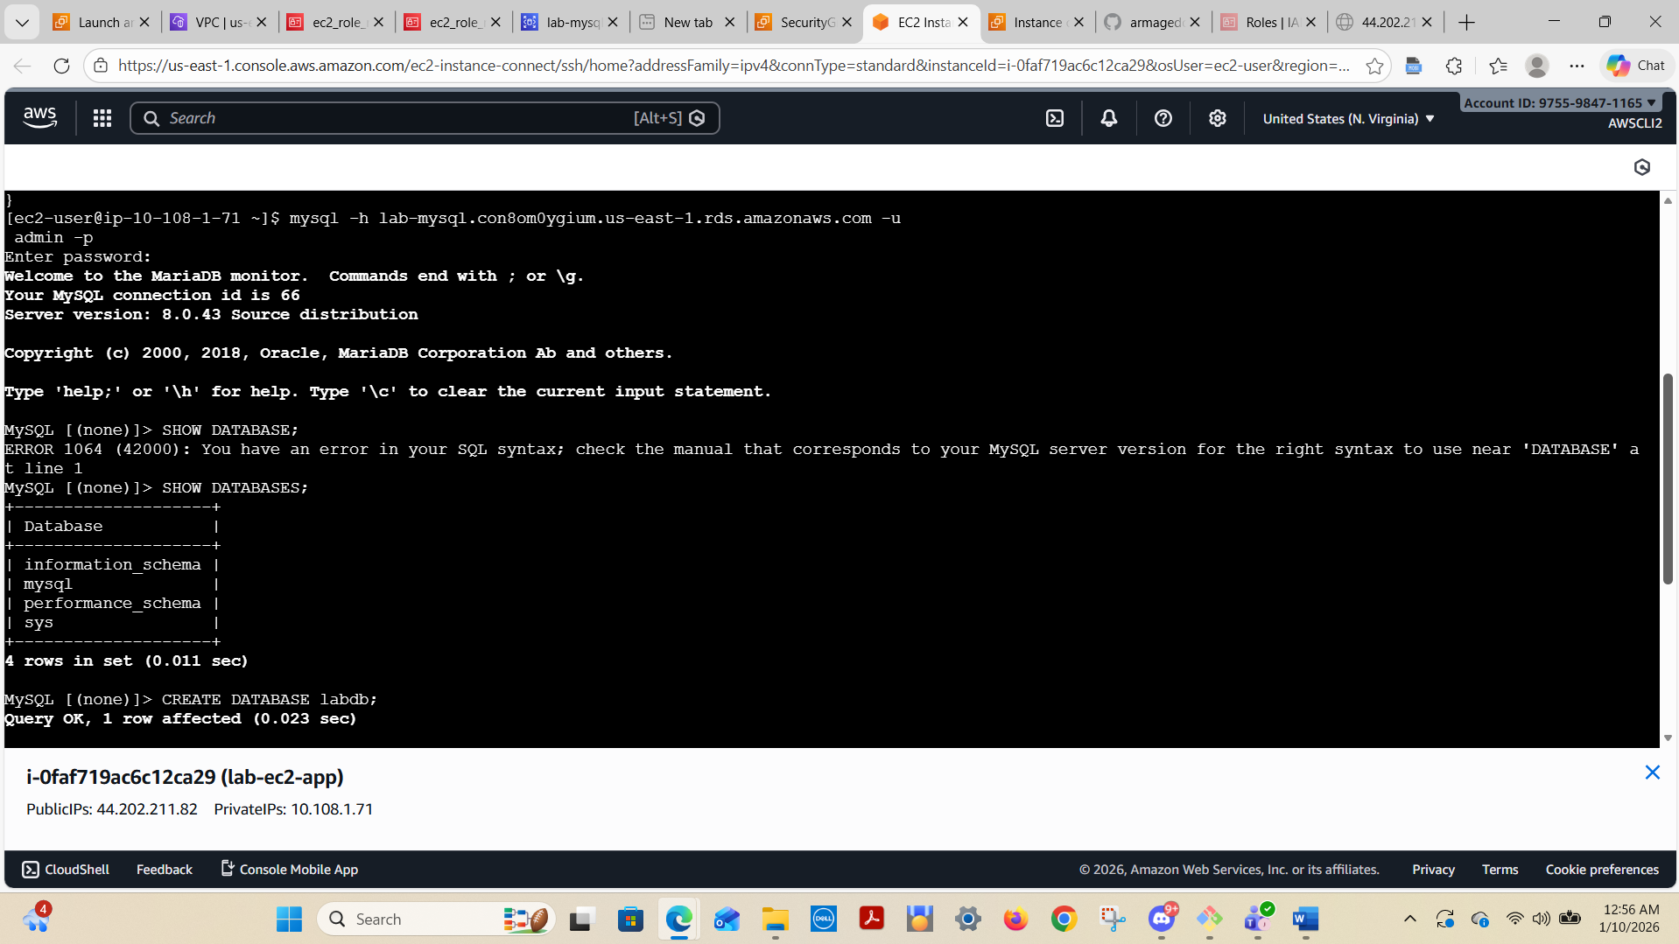
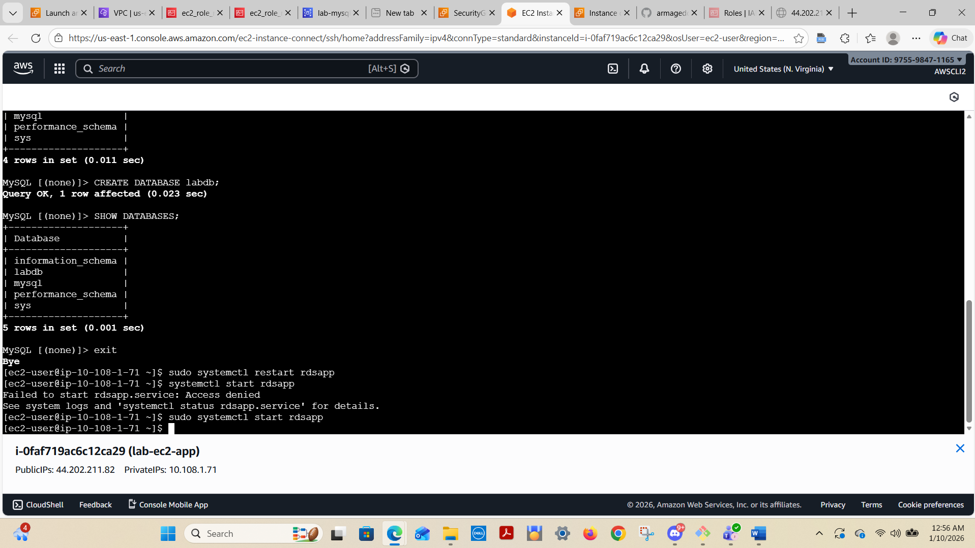
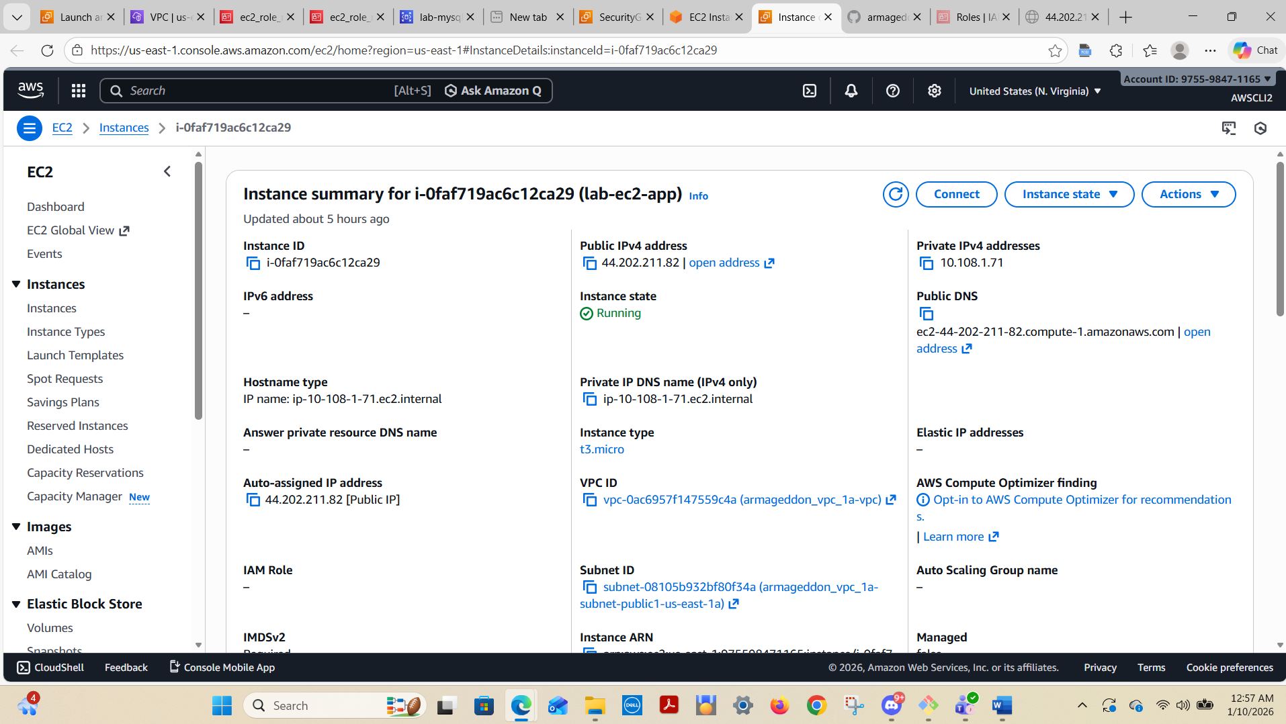

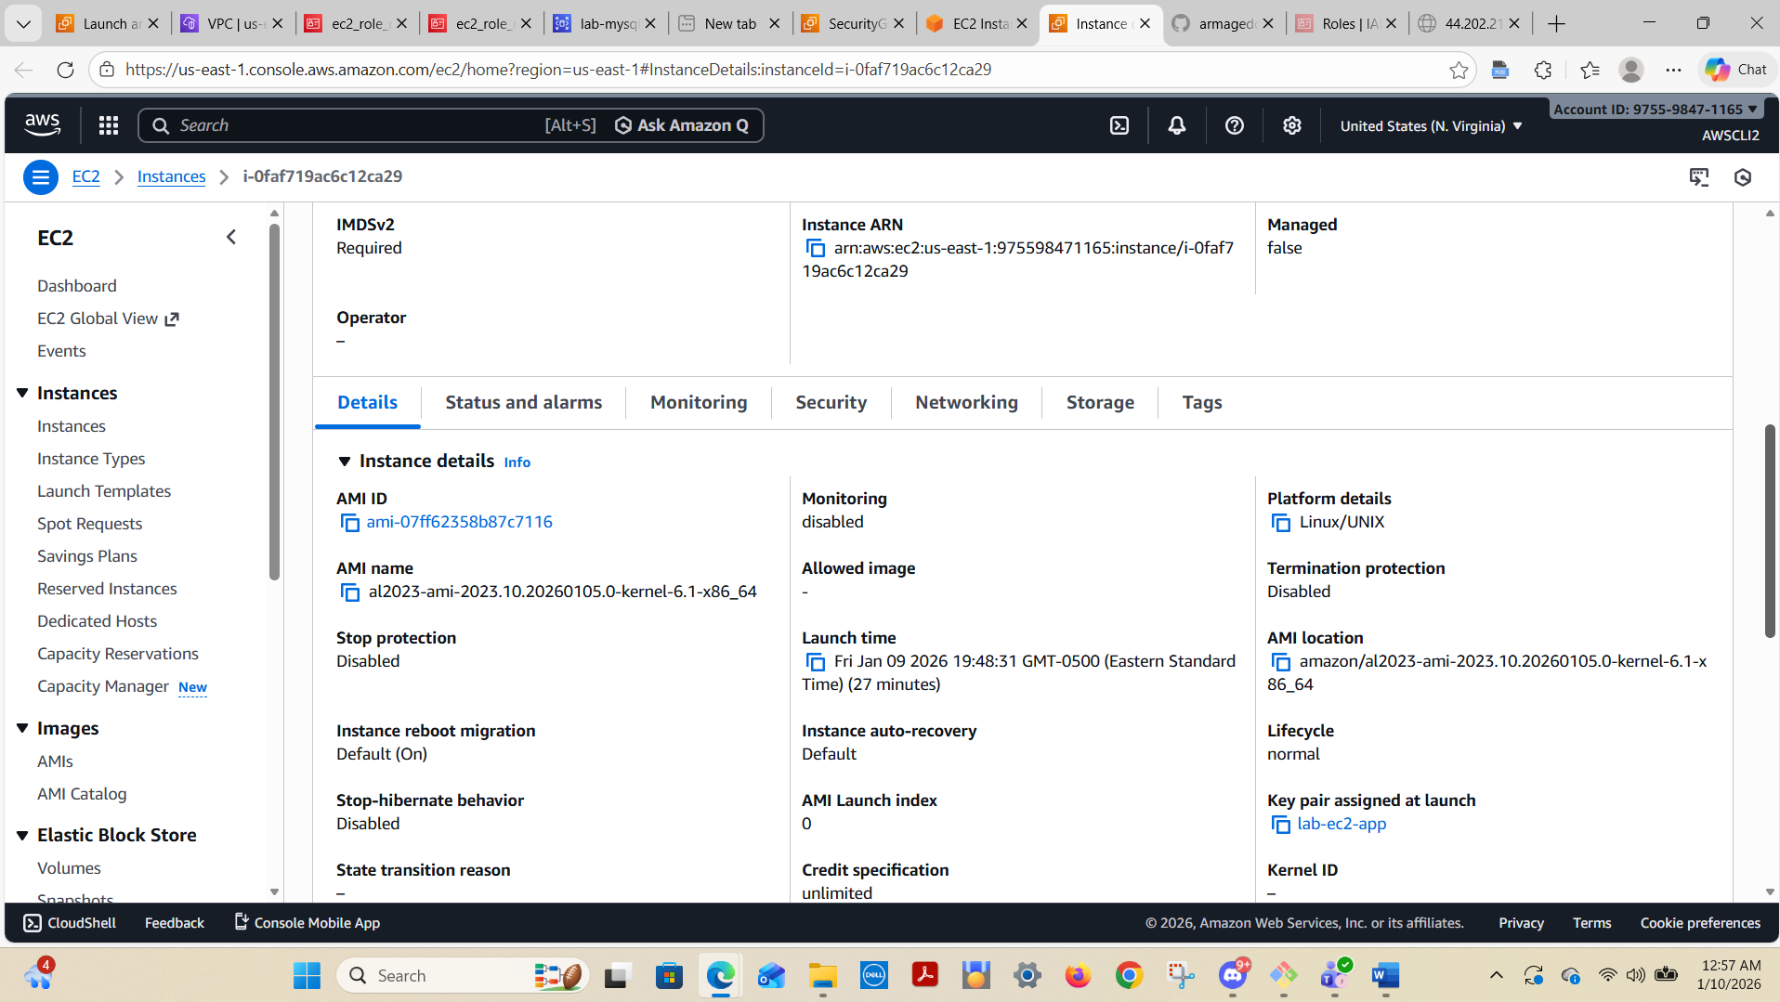
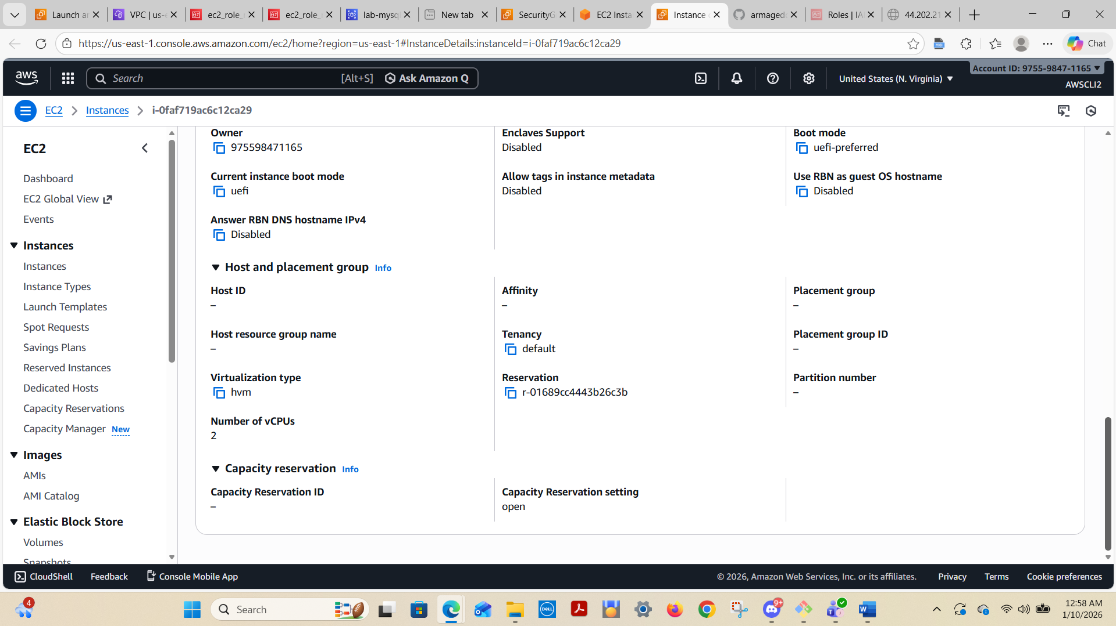
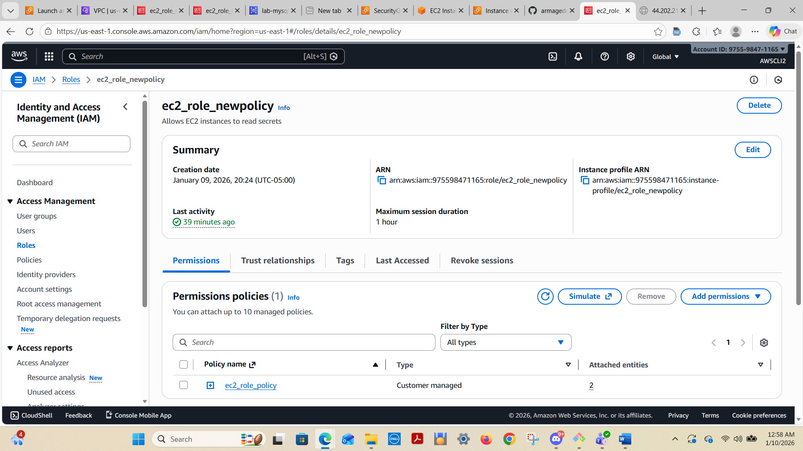
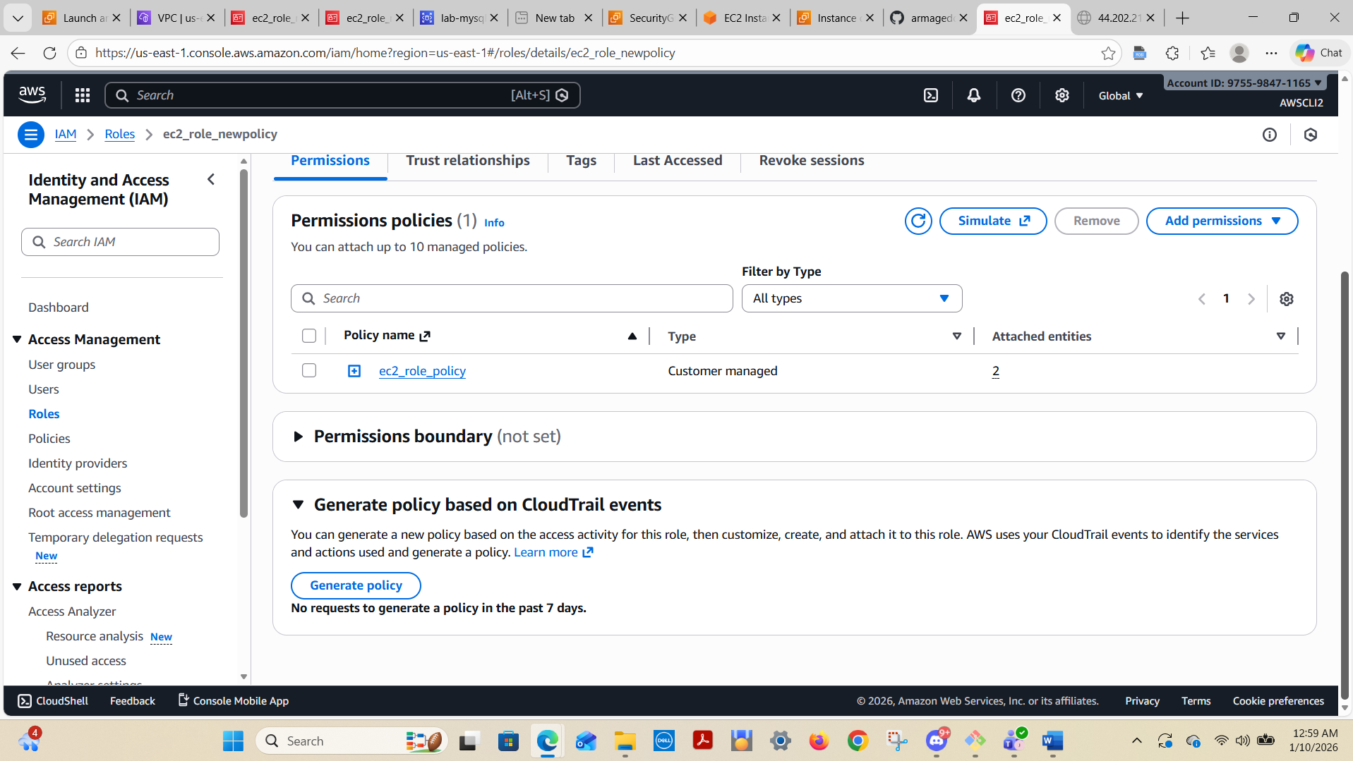

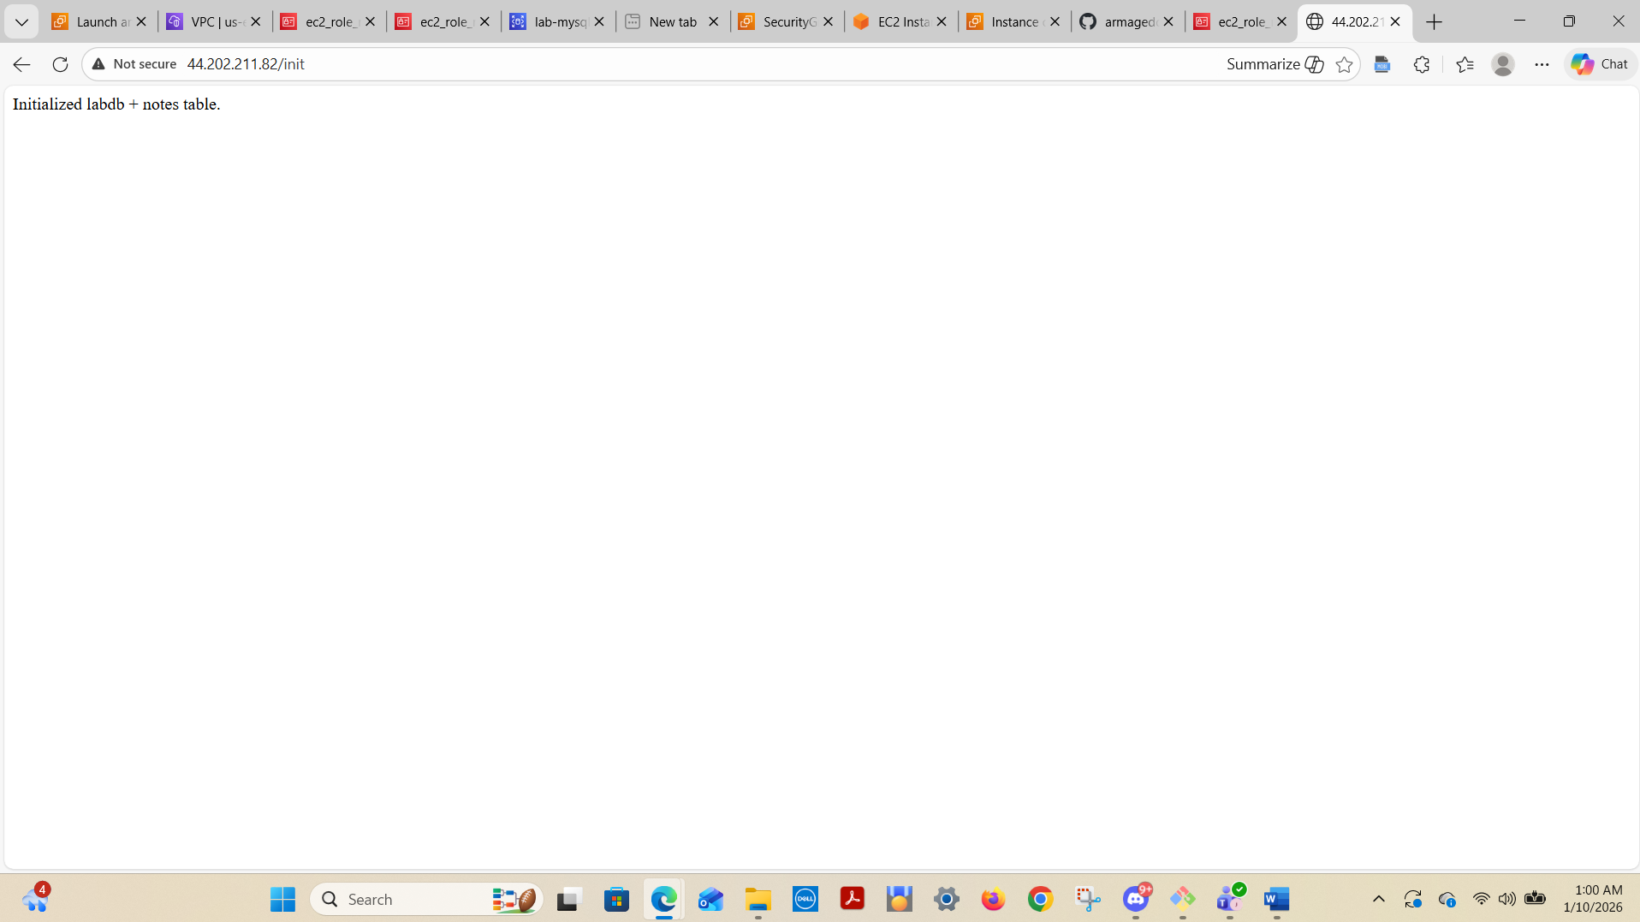
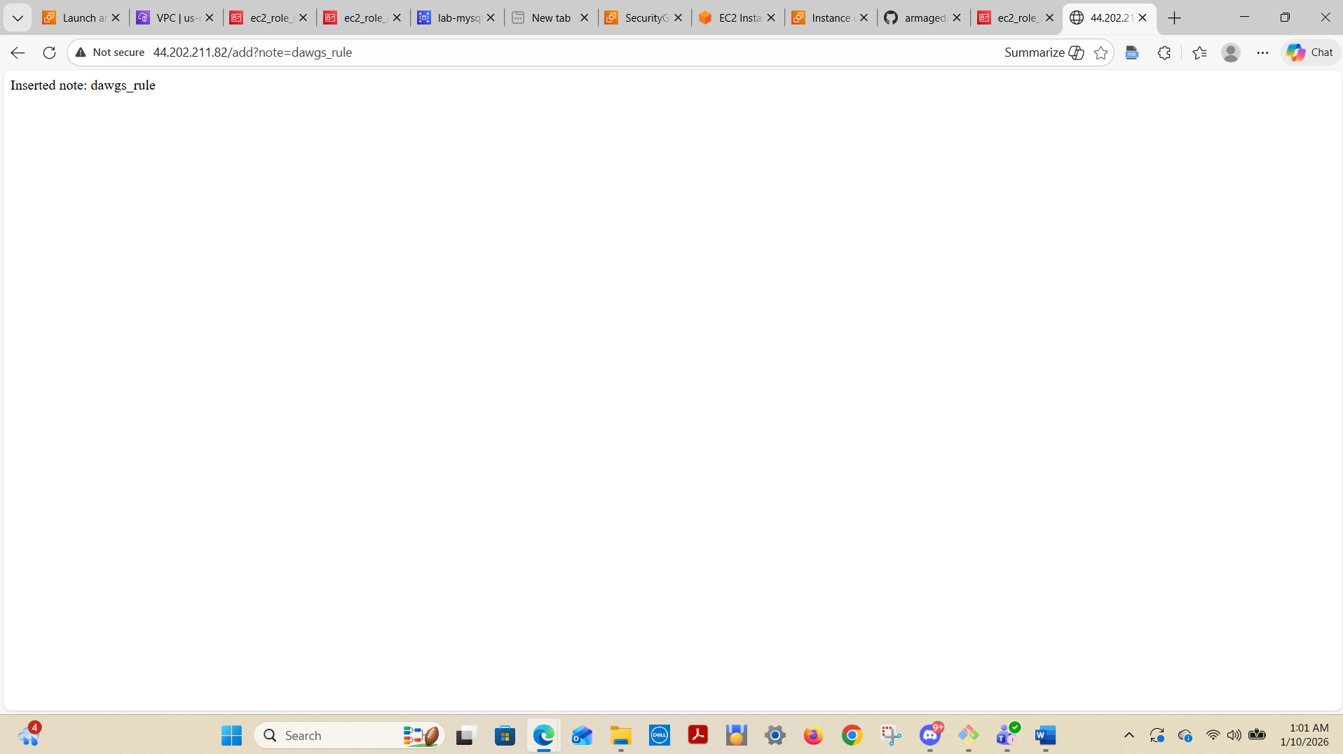

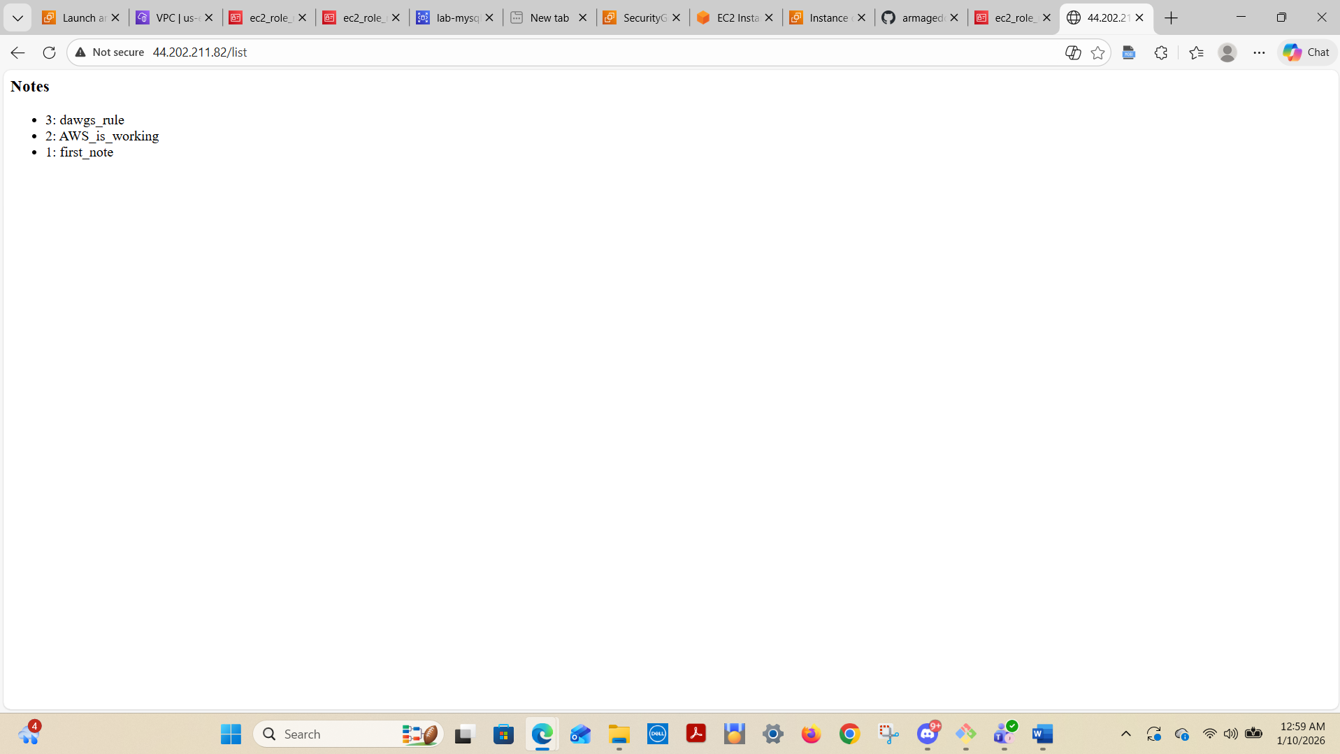

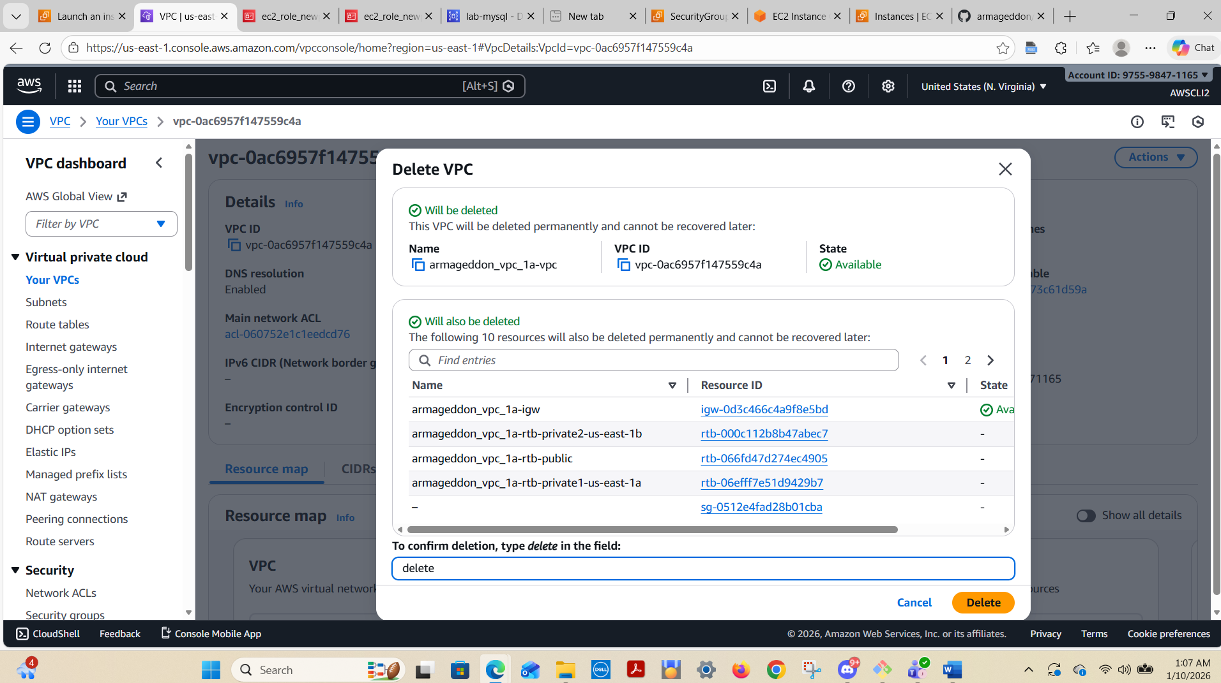

Permissions Policy:
{
"Version": "2012-10-17",
"Statement": [
{
"Sid": "ReadOnlyListActions",
"Effect": "Allow",
"Action": [
"ec2:DescribeInstances",
"ec2:DescribeSecurityGroups",
"rds:DescribeDBInstances"
],
"Resource": "*"
},
{
"Sid": "ReadSpecificSecret",
"Effect": "Allow",
"Action": [
"secretsmanager:GetSecretValue"
],
"Resource": "arn:aws:secretsmanager:<region>:<account Id>:secret:lab/rds/mysql*"
}
]
}

1.) Screenshot of:
RDS SG inbound rule using source = sg-ec2-lab
EC2 role attached
/list output showing at least 3 notes
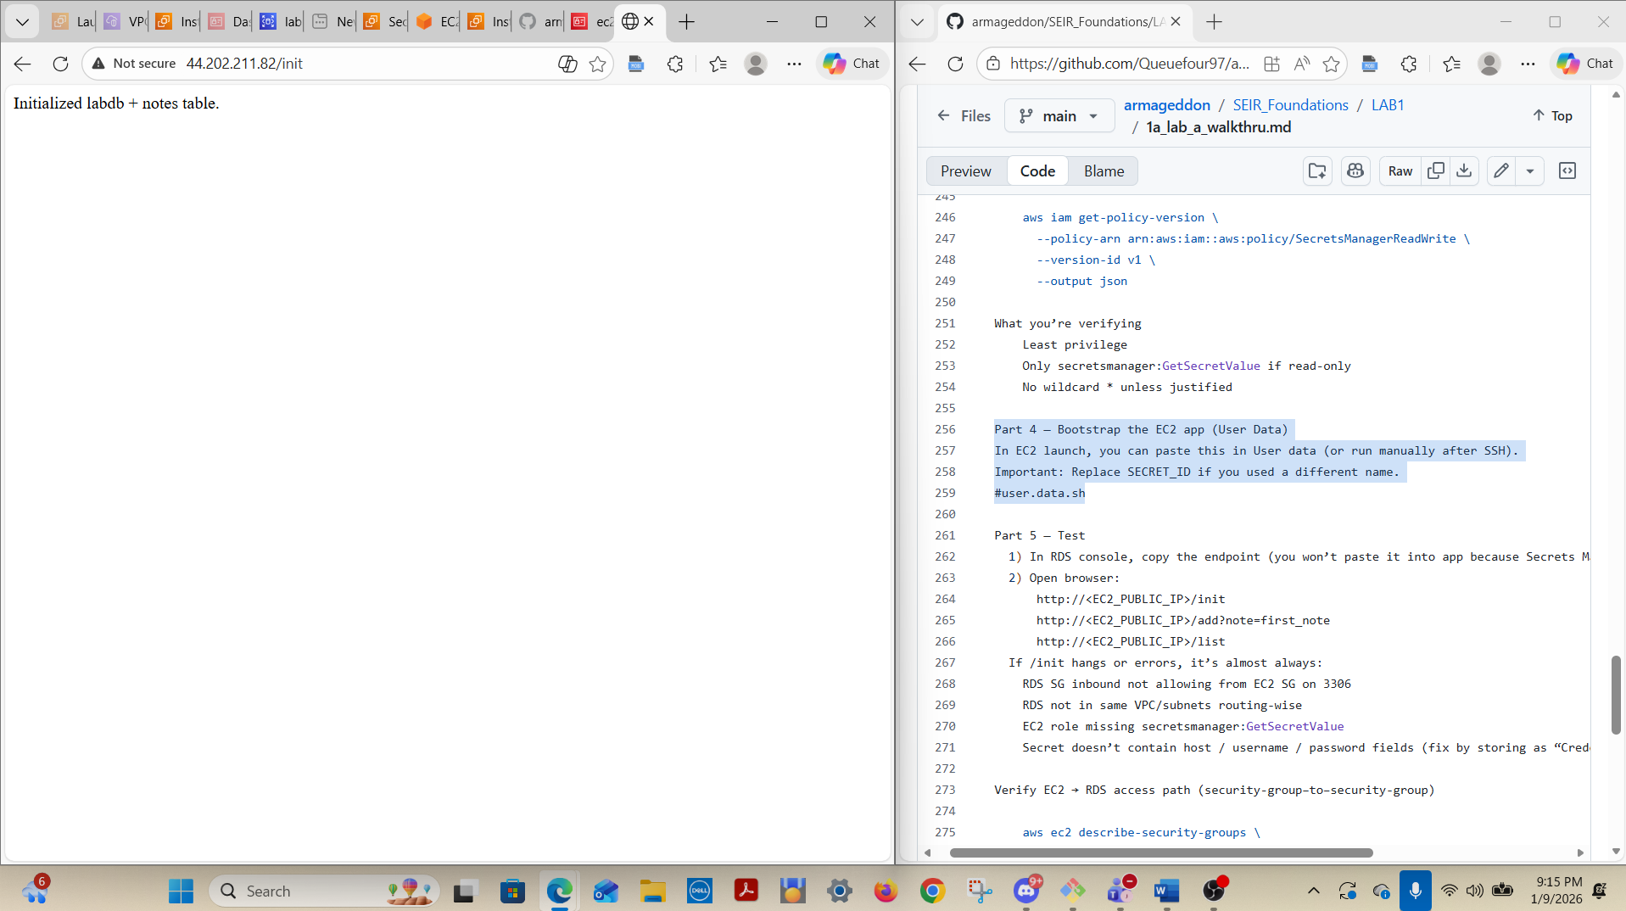

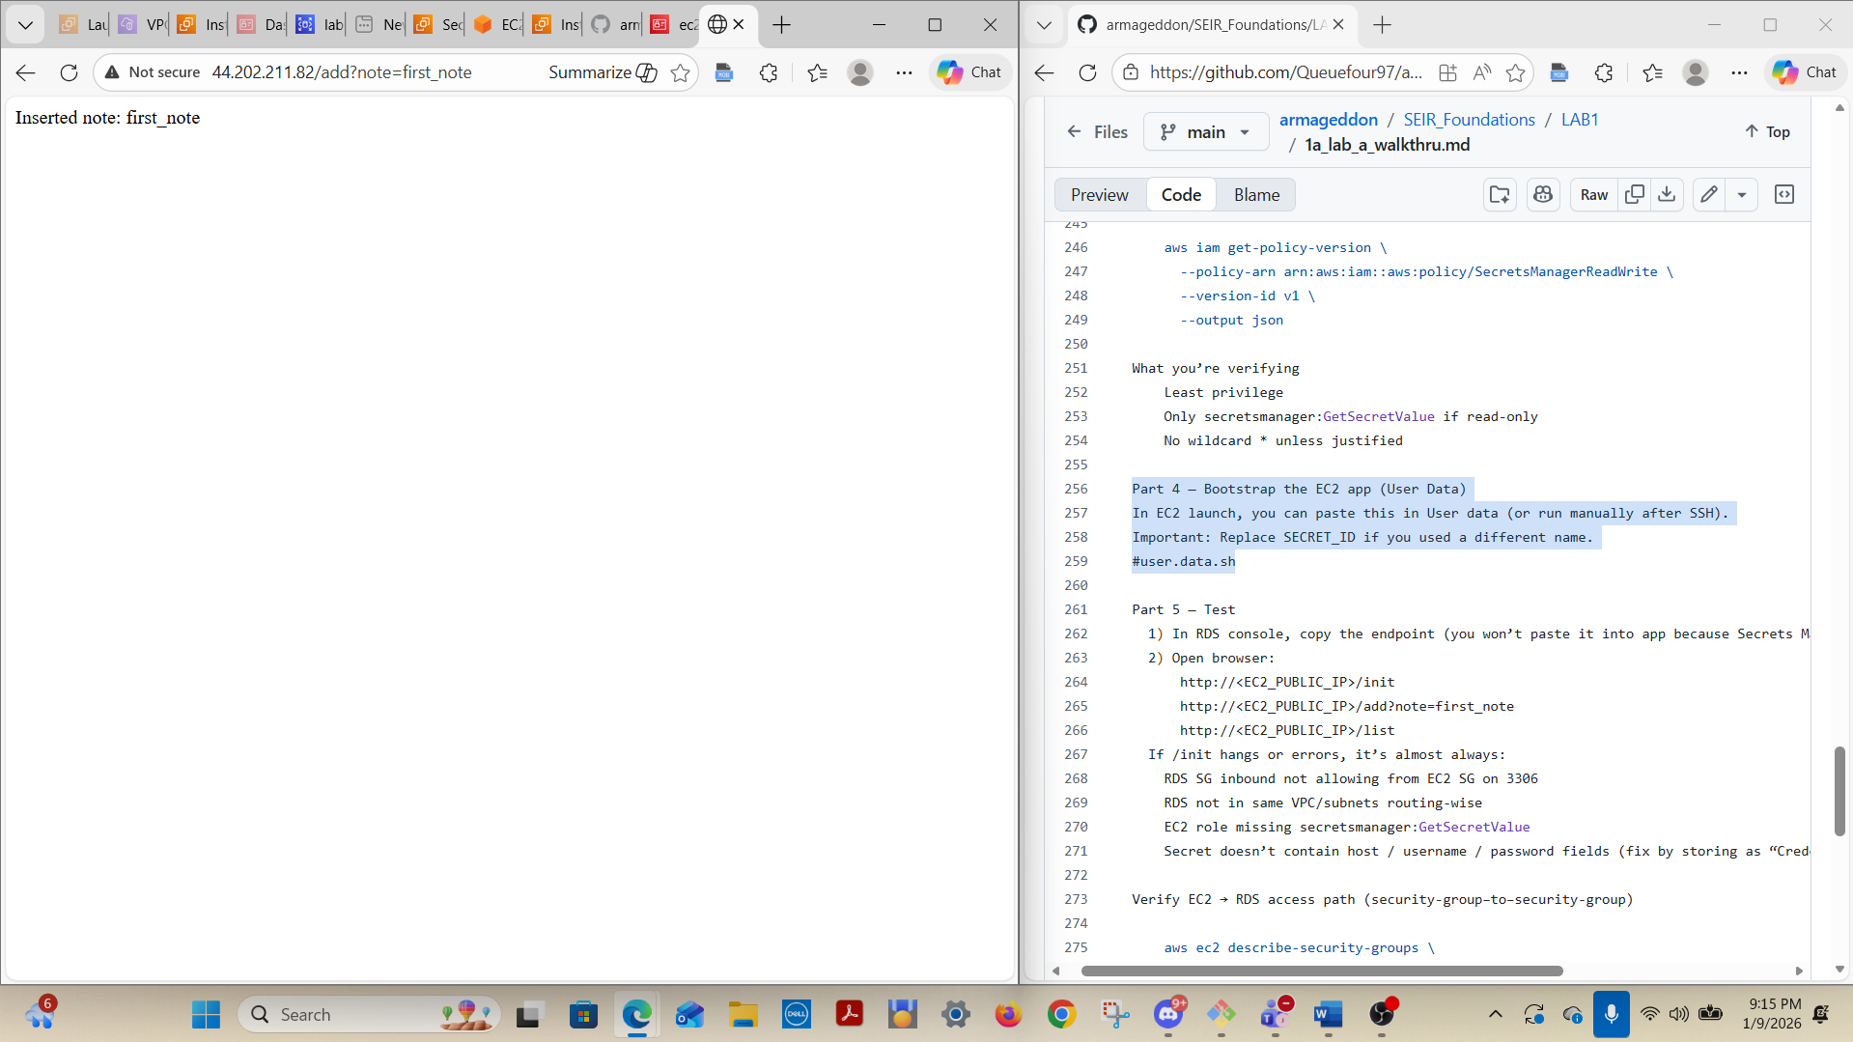

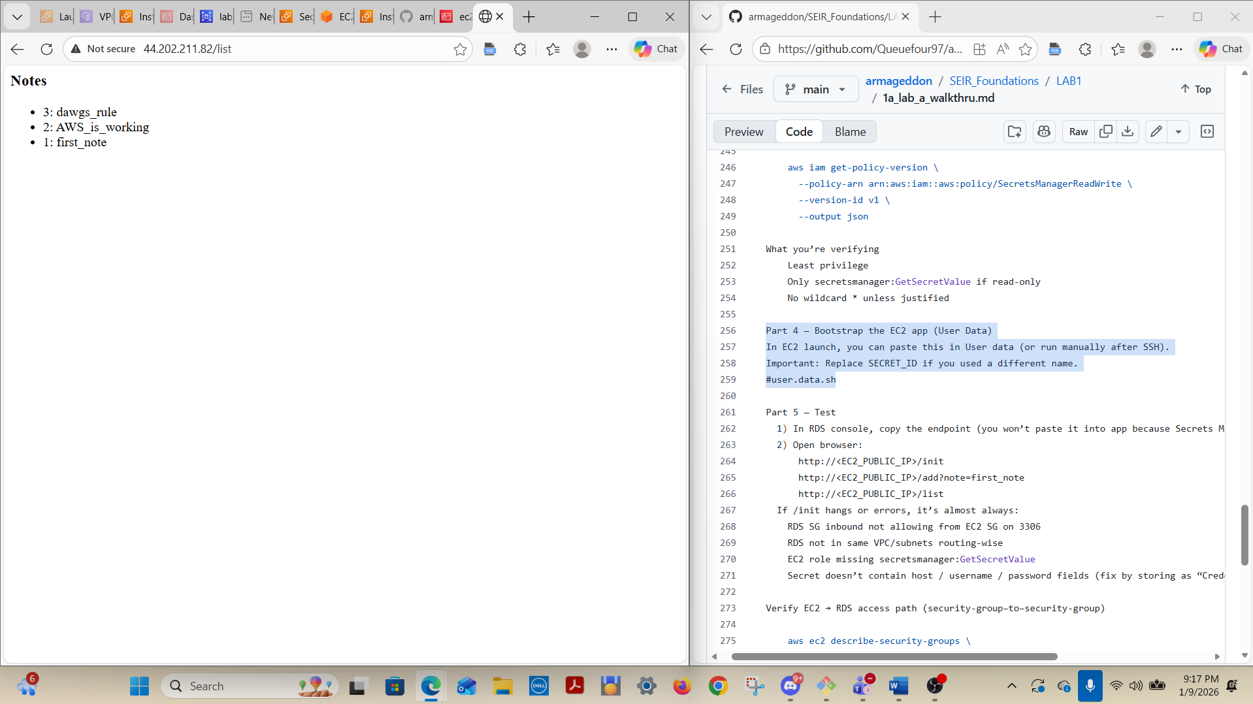

RDS Inbound Rule Screen Shot:
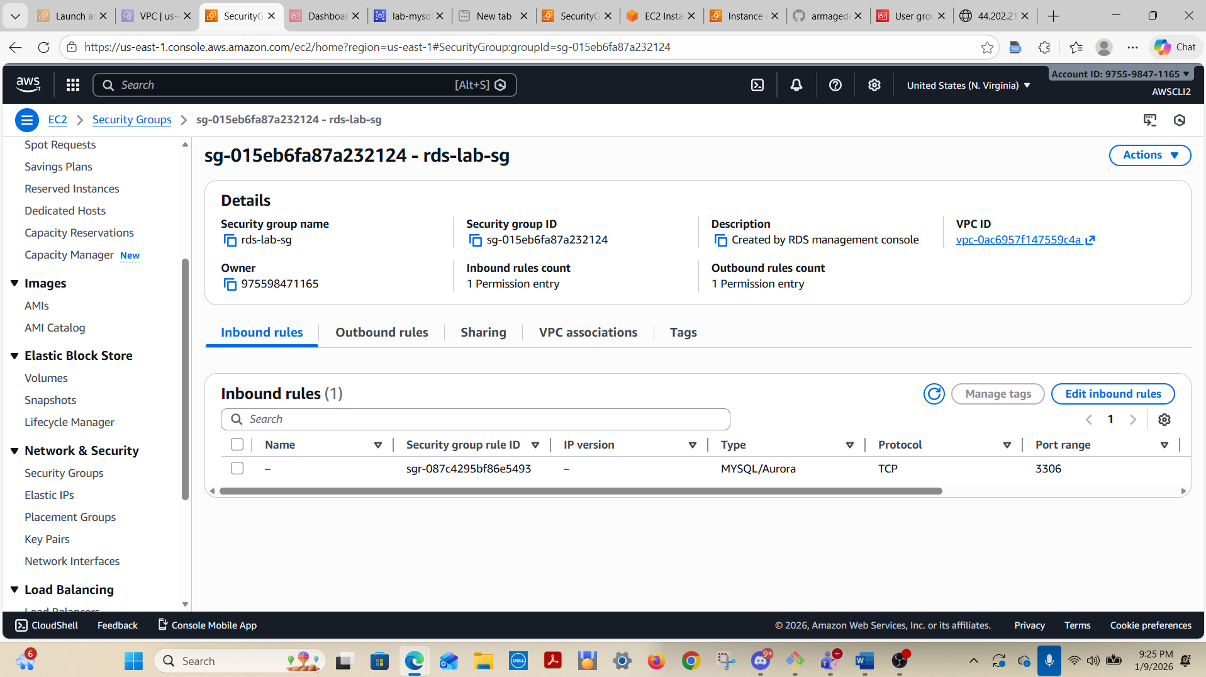
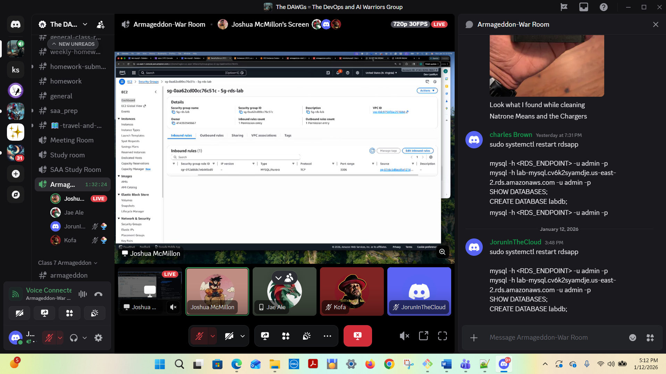



aws sts get-caller-identity
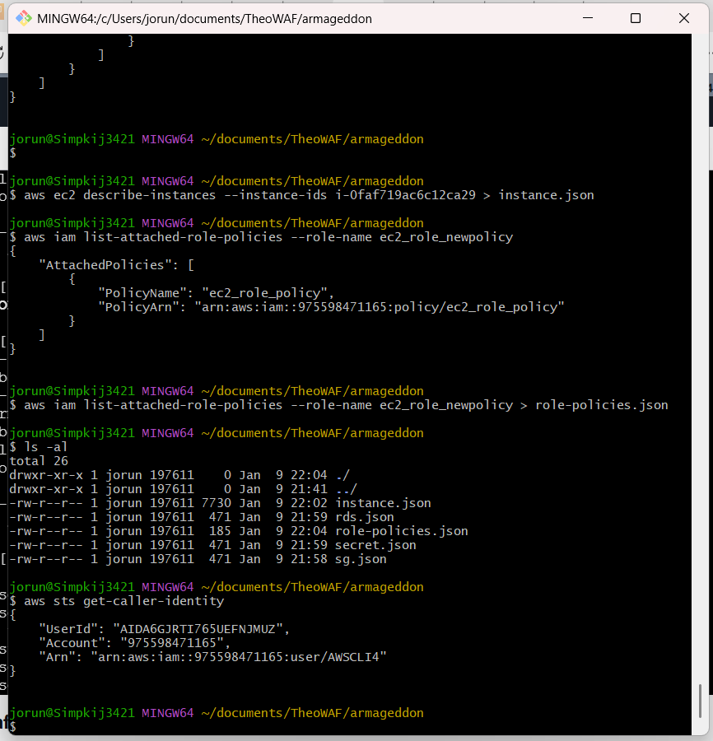

RDS running in same VPC
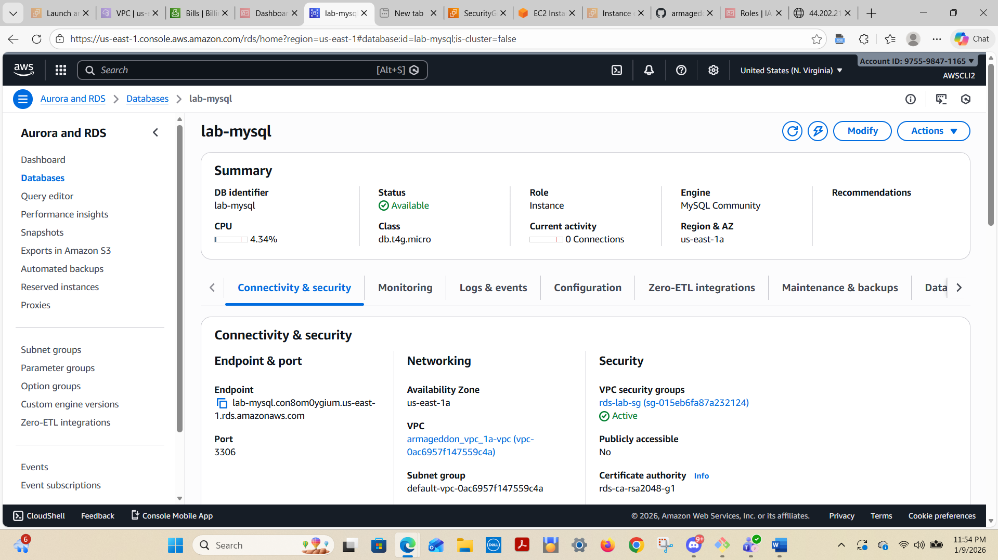

2) Short answers:
A) Why is DB inbound source restricted to the EC2 security group?
DB inbound source restricted to the EC2 security group because we only want incoming traffic to the DB for access control. It is a more secure way to determine the source. As long as the security group remains static and the same, access is controlled. No matter how many instances are made, the Security Group will govern access.
B) What port does MySQL use? 3306
C) Why is Secrets Manager better than storing creds in code/user-data?
Greater security; Secrets manager allows you to store it in a more secure environment; Storing creds in code/user-data is more susceptible to hack or intrusion

- Why each rule exists
Inbound Rules for EC2:
HTTP
Type: HTTP Protocol: TCP Port: 80 – exists to allow all incoming traffic (0.0.0.0/0) on port 80 to the EC2; HTTP is used to establish a connection to RDS via the Public IP address of the EC2.

SSH
Type: SSH Protocol: TCP Port: 22 – exists to allow incoming traffic on port 22 to the EC2; Additionally this port will allow a SSH session to be established (via BASH or other ) to the EC2, to access the RDS. The RDS SG inbound rule Set Source = sg-ec2-lab for TCP 3306, restricts access to the designated IP only in the Source of the SSH Security Group rule

Note: We don’t alter Outbound Rules or Chewbacca will alter us…..!!!!
- What would break if removed
If the Inbound Rules are removed there would be no access HTTP via IP and SSH from the designated IP (ability to receive incoming traffic) to the EC2 or RDS (database).

- Why broader access is forbidden
Broader access is forbidden to maintain access control of incoming traffic

- Why this role exists
The IAM Role exists and is attached to the EC2 instance, so that the EC2 is able to read the secret.

- Why it can read this secret
It can read the secret because the role is successfully attached to the EC2 instance.

- Why it cannot read others
It cannot read others because the policy in the role is restricted. Least privilege prevents credential leakage & lateral movement. Security Model RDS is not publicly accessible RDS only allows inbound traffic from the EC2 security group EC2 retrieves credentials dynamically via IAM role No passwords are stored in code or AMIs.

